2016 Holt Invitational
Wind Power Test

School / Team Name (Please remember to indicate if you are an A or B team from your school if appropriate):

______________________________________

Team # _______

Student name(s):

___________________________________________ ___________________________________________

Low Speed Power Score _______ High Speed Power Score _______

Part I (Power) Score (50 pts) _________

Part II (Exam) Score (50 pts) ________

Total Score (100 pts) _________

Final Ranking: ______

(Tiebreaker: #1 – highest high speed voltage; #2 highest low speed voltage)

1) What orientation does the rotor shaft of a wind turbine need to be in in order to operate?

A) horizontal (parallel to the ground)

B) vertical (perpendicular to the ground)

C) the orientation depends on the design of the turbine

2) Name one advantage a turbine design with less blades has, and one advantage a design with more blades has.

Answer: Less blades = less weight and drag; more blades = more surface area to catch the wind. Also, stability can be a factor. More blades are usually more stable and balanced.

3).What is the effect of a rotor with high solidity ( > 0.80)?

A) high speed high torque B) high speed low torque

C) low speed high torque D) low speed low torque

4) Some experimental wind turbines have incorporated an added structural design feature, called a/an _________, intended to increase the amount of wind passing through the blades.

Answer = augmentor

5) Name the requested parts of the wind turbine in the picture below.
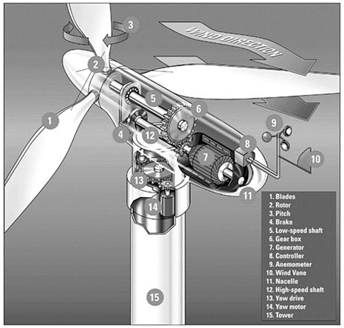

Part 1. Blades

Part 2. Rotor

Part 5. (Low Speed) Shaft

Part 7. Generator

Part 9. Anemometer

Part 10. Wind Vane

6) What percent of power in the U.S. is generated by renewable sources?

Answer: 13% of energy produced and 10% of energy consumed.

7) What is Betz’s Limit for wind turbines?

Answer: the maximum efficiency of a turbine cannot exceed 59%.

8) How is a turbine used to generate electricity?

Answer: moving liquid or gas (water or air) rotate blades or other structures which in turn rotate coils of wire around magnets. Using the principal of electromagnetic induction, electricity is produced.

9) Given a wind turbine with blade length 20 meters from the center and air speed 13 meters per second and air density of 1.1 kilogram per meter cubed, what power would it generate if it were 40% efficient? Express your answer in megawatts.

Answer: P = 0.5 x density x πR² x V³x efficiency = 0.5 x 1.1 x π x 202 x 133 x 0.40 = 607383 = 0.61 MW

10) Using the diagram below, calculate the difference in one hour in joules of the energy difference between the Vestas V-90 2.0 MW turbine and the 1.8 MW turbine if the wind is a constant 12 m/s for that hour?

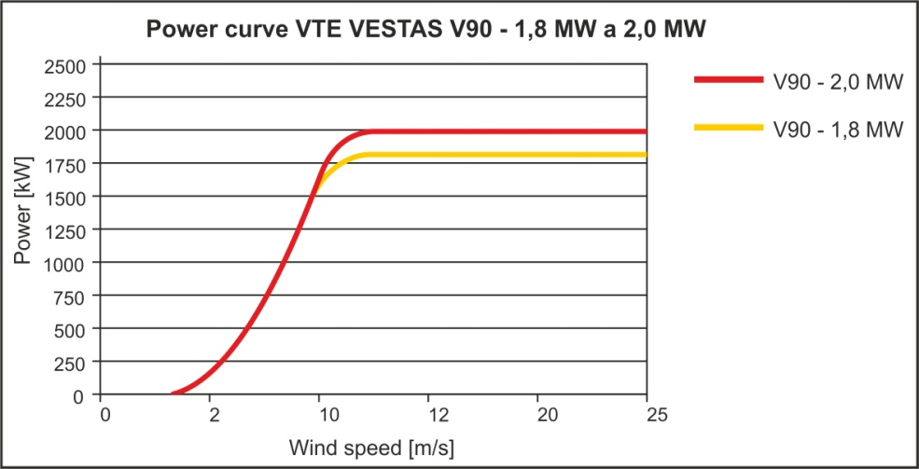

Answer: 200 watt difference x 3600 seconds per hour = 720000 joules

11) Give at least two reasons why energy, once it’s produced, might need to be stored instead of used.

Answer: energy demand does not always coincide with energy production – both time of day and location are factors.

12) Explain how pumping water can be used as a power storage mechanism.

Answer: during peak generating hours, energy from wind is used to pump water to a higher elevation. During off-peak generating hours which may coincide with peak usage hours, water is released from the higher elevation to allow gravity make it flow past turbines

13) Name 4 types of mechanical energy storage.
1. _________________________________ 2.___________________________________
3. _________________________________ 4. ___________________________________

Different Possible Answers: Pumped Storage, Hydroelectric dams, Compressed Air, Flywheel Energy Storage, Gravitational potential energy storage, Thermal storage

14) Where (in general climate regions) is the use of heat storage to store wind energy most suitable?

Answer = Northern climates

15) At what time is energy most likely to be stored in an energy storage facility? (1pt)

A) 3 AM B) 9 AM C) 3 PM D) 9 PM

16. What does a transformer do?

Answer: Adjust voltage of electricity.

17. All energy supposedly comes from the sun. Describe in detail how the energy from the sun would warm a cup of cocoa in your microwave if you used wind power.

Answer: The sun causes uneven heating of the earth’s surface, creating wind as warm air rises and moves. The wind rotates a blade on a wind turbine, rotating a coil of wire near magnets creating electricity, which is transmitted to either a power station or a storage facility. The electricity is then moved to the home where it enters the house and powers the microwave, whose waves excite the cocoa and cause it to heat.

18) If you ran a 60-watt bulb for 20 days and electricity costs are 12¢ per kWh, how much would it cost to run the bulb during that time?

Answer: 60 x 20 x 24 / 1000 x 0.12 = $3.456

19) A 40 km long electrical power line supplies 700 MW on a 400 KV line. The line has a resistance of 0.2 ohms per km. What is the voltage drop between the ends of the line?

Answer: 700 MW / 400 KV = 1,750 A 1,750 A x 40 x 0.2 = 14kV

20. In the above situation, how much power is lost in the line?

Answer: 1,750 A x 14kV = 24MW

21) Windmills were first showcased at the Chicago World Fair in what year?

Answer: 1893.

22) In the late 1990’s what percentage of California’s energy was generated by wind?

Answer = nearly 2%

23) What orientation did the first windmills have, and what two main purposes were they used for?

Answer: vertical axis orientation, used for grinding grain and pumping water

24) What and where was the first windmills used in the U.S. to provide electricity to the local utility company?

Answer: Vermont’s Smith-Putnam machine in 1941

25) Where were the first utility-scale wind energy conversion systems set up?

Answer: The development of bulk-power, utility-scale wind energy conversion systems was first undertaken in Russia in 1931 with the 100kW Balaclava wind generator. This machine operated for about two years on the shore of the Caspian Sea.

