Science Olympiad
Optics Test Division B
Holt Invitational
School Name:___________________________________

Team Number: _________________________________

- Please do not open this test until instructed to do so.

- All multiple point, fill-in-the-blank, and true/false questions are 1 point each

- Tiebreakers start with question #1 and go to end of test

- After starting, you will have the remainder of the period to complete the test, minus the time spent for the Laser Shoot.

- All numerical answers (non multiple choice) will require correct units and significant digits.

- The splitting of visible light by a prism into the color spectrum is called
  - Deviation
  - Dispersion
  - Reflection
  - Filtering

- If a human sees an object as Magenta, what primary color of light is being absorbed by the object (assume use of white light)?

- Sunlight reflecting off choppy water, without a clear image is an example of what type of reflection?
- Secular
- Diffuse

- How many colors of light are being used on the screen shown below?
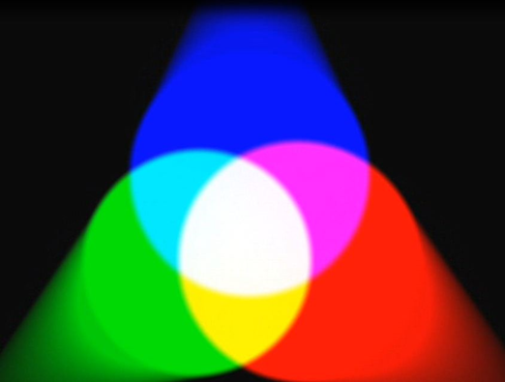

- The mathematic relationship between the speed of light in various mediums to the index of refraction is N=c/v. In this equation, the variable v stands for:
  - The speed of light in a vacuum
  - The speed of sound in a vacuum
  - The velocity of the mass the light is entering/leaving
  - The speed of light in the medium being measured
  - The wavelength of the light being used

- What two primary colors of light make up yellow light?

- Using the edges of this paper as plain mirrors, trace the path of light for a total of 4 reflections and circle which object it will then reach

8-11: Identify the objects in the diagram below with the following terms:
- Image_________
- Focal point__________
- Center of curvature_________
- Real object___________
D

C

B
A

- The purpose of the cones in the human eye are to:
  - Control the focus of the eye to be able to see sharp images
  - Identify the frequency of the light hitting the retina
  - Identify the intensity of the light hitting the retina
  - Protect the eye from receiving too much light and being damaged

- Using a triangular glass prism, a form of light with a longer wavelength will have a ________ angle of deviation.
  - Higher
  - Lower

- Label the components of the telescope below. Describe the type of each optical object (convex or concave, lens or mirror). Also identify the type of telescope this represents.
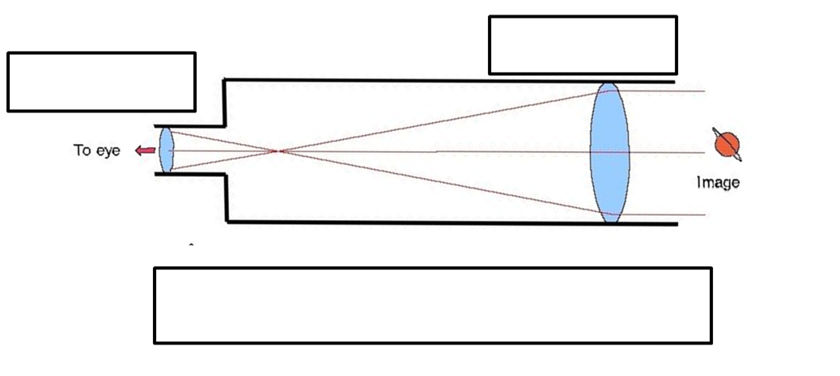

- In the diagram above, describe the difference in the focal points of the two objects.

- A convex mirror always creates what type of image (real / virtual, orientation, size)?

17-21:Identify the letter in the diagram with the name listed for each number.

- Angle of Reflection_______

- Incident ray_____________

- Normal line_____________

- Angle of Incidence_______

- Reflection ray___________

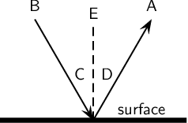

- What is the relationship between the focal point and the center of curvature in a concave mirror?

- When two polarizing lenses with parallel alignments are placed over one another, no light is visible.
  - True
  - False

- If the speed of light in air is 2.9970 x 10⁸ m/s, what is the index of refraction of water? Note: the speed of light in a vacuum is 2.99792458 x 10⁸ m/s

- True / False: A convex lens always produces a virtual image.

- If the object in front of a concave mirror is between the center of curvature and the focal point, what an observer sees is an ____________.
  - Inverted, miniature, real image
  - Upright, miniature, virtual image
  - Inverted, magnified, real image
  - Upright, magnified, real image

- A pure pigment is a substance that absorbs a single frequency of light. What color does a pure yellow pigment absorb?

- Trace three rays for the man and the convex lens below, and draw the image. The points closest to the lens are F and F’, the outside points are 2F and 2F’.
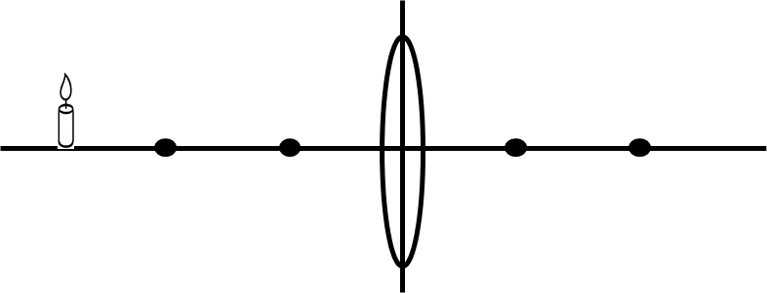

- If an object is placed outside the center of curvature of a convex mirror, what type of image is formed?
  - Inverted, miniature, real image
  - Upright, miniature, virtual image
  - Inverted, magnified, real image
  - Upright, magnified, real image

- Name the secondary colors of light for the human eye.

- True or False: The image below is a diagram showing diffuse reflection.

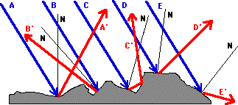

- The approximate index of refraction for the human cornea is:
  - 1.03
  - 1.80
  - 1.53
  - 1.38

- If an object 8.7 cm tall is placed 9.0 cm in front of a convex lens with a focal point distance of 6.0 cm, how far from the mirror is the image located?

- In the same scenario from previous question, what is the size of the image formed?

- Since the cornea and lens combination acts as a converging lens (or a double convex lens), and the objects being viewed are more than twice the focal length away, the images formed on the retina are:
  - Real
  - Inverted
  - Magnified (enlarged)
  - A and B

- The picket fence analogy shown below is similar to polarization via a ____________. In making a film of this type, long molecules are stretched across the surface in parallel lines that block waves that are aligned perpendicular to the molecules.
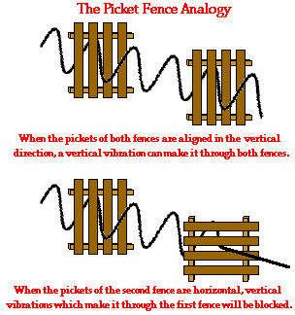
- True / False: A difference between a converging lens and a diverging lens is that a diverging lens is thicker in the middle than at the ends and a converging lens is thicker at the ends than in the middle.

- Film coatings can be used to protect human eyes from damaging light sources.
  - True
  - False

