Science Olympiad
Optics Test Division B
Holt Invitational
School Name:___________________________________

Team Number: _________________________________

- Please do not open this test until instructed to do so.

- All multiple point, fill-in-the-blank, and true/false questions are 1 point each

- Tiebreakers start with question #1 and go to end of test

- After starting, you will have the remainder of the period to complete the test, minus the time spent for the Laser Shoot.

- All numerical answers (non multiple choice) will require correct units and significant digits.
- The splitting of visible light by a prism into the color spectrum is called
  - Deviation
  - Dispersion - Correct answer
  - Reflection
  - Filtering

- If a human sees an object as Magenta, what primary color of light is being absorbed by the object (assume use of white light)?

Green

- Sunlight reflecting off choppy water, without a clear image is an example of what type of reflection?
- Secular
- Diffuse - Correct answer

- How many colors of light are being used on the screen shown below? Three
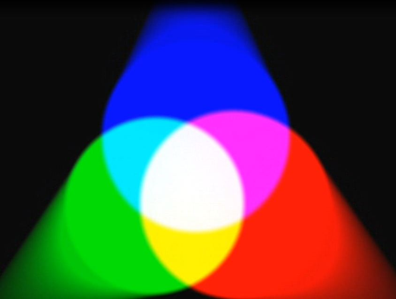

- The mathematic relationship between the speed of light in various mediums to the index of refraction is N=c/v. In this equation, the variable v stands for:
  - The speed of light in a vacuum
  - The speed of sound in a vacuum
  - The velocity of the mass the light is entering/leaving
  - The speed of light in the medium being measured
  - The wavelength of the light being used

- What two primary colors of light make up yellow light?
Red and Green
- Using the edges of this paper as plain mirrors, trace the path of light for a total of 4 reflections and circle which object it will then reach

rectangle
8-11: Identify the objects in the diagram below with the following terms:
- Image_________A
- Focal point__________C
- Center of curvature_________B
- Real object___________D
D

C

B
A

- The purpose of the cones in the human eye are to:
  - Control the focus of the eye to be able to see sharp images
  - Identify the frequency of the light hitting the retina
  - Identify the intensity of the light hitting the retina
  - Protect the eye from receiving too much light and being damaged

- Using a triangular glass prism, a form of light with a longer wavelength will have a ________ angle of deviation.

  - Higher
  - Lower - Correct answer

- Label the components of the telescope below. Describe the type of each optical object (convex or concave, lens or mirror). Also identify the type of telescope this represents.
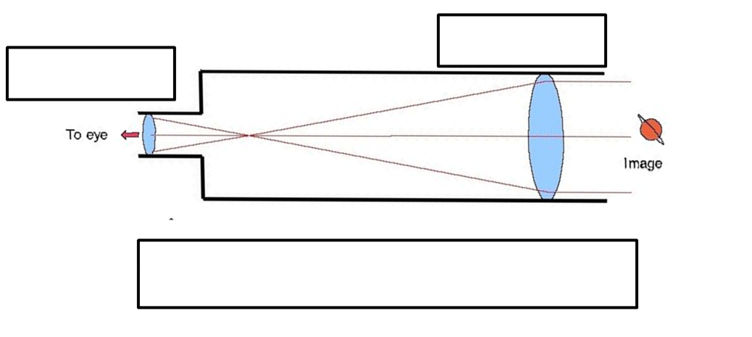
2 convex lenses (primary and eyepiece) in a refracting telescope

- In the diagram above, describe the difference in the focal points of the two objects.

The Primary lens has a much longer focal length than the eyepiece lens.

- A convex mirror always creates what type of image (real / virtual, orientation, size)?

Virtual, upright, miniature size

17-21:Identify the letter in the diagram with the name listed for each number.

- Angle of Reflection_______D
- Incident ray_____________B
- Normal line_____________E
- Angle of Incidence_______C
- Reflection ray___________A

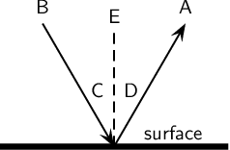

- What is the relationship between the focal point and the center of curvature in a concave mirror?

The center of curvature is twice the distance from the mirror as the focal point.

- When two polarizing lenses with parallel alignments are placed over one another, no light is visible.
  - True
  - False

- If the speed of light in air is 2.9970 x 10⁸ m/s, what is the index of refraction of water? Note: the speed of light in a vacuum is 2.99792458 x 10⁸ m/s
N=c/v = 299700000/299792458 = 1.0003

N is the index of refraction for a substance, c is the speed of light in a vacuum (2.99792458 x 10⁸ m/s), v is the velocity of light in the substance

- True / False: A convex lens always produces a virtual image.

- If the object in front of a concave mirror is between the center of curvature and the focal point, what an observer sees is an ____________.
  - Inverted, miniature, real image
  - Upright, miniature, virtual image
  - Inverted, magnified, real image - Correct answer
  - Upright, magnified, real image

- A pure pigment is a substance that absorbs a single frequency of light. What color does a pure yellow pigment absorb?
Blue, the pigment’s complementary color

- Trace three rays for the man and the convex lens below, and draw the image. The points closest to the lens are F and F’, the outside points are 2F and 2F’.
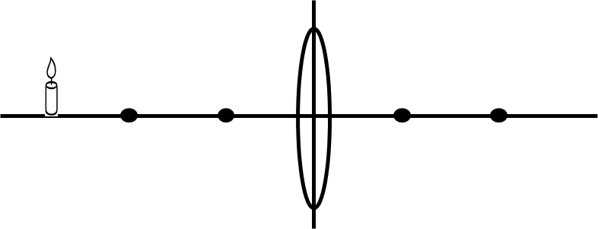
Image should be inverted, on right, identical size, at the 2F points

- If an object is placed outside the center of curvature of a convex mirror, what type of image is formed?
  - Inverted, miniature, real image - Correct answer
  - Upright, miniature, virtual image
  - Inverted, magnified, real image
  - Upright, magnified, real image

- Name the secondary colors of light for the human eye.

Yellow, Cyan, Magenta

- True or False: The image below is a diagram showing diffuse reflection.

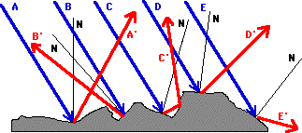

- The approximate index of refraction for the human cornea is:
  - 1.03
  - 1.80
  - 1.53
  - 1.38

- If an object 8.7 cm tall is placed 9.0 cm in front of a convex lens with a focal point distance of 6.0 cm, how far from the mirror is the image located?

$\frac{1}{F}=\frac{1}{D_{o}}+ \frac{1}{D_{i}}$ , D_{i} = 1 / (1/6 – 1/9) = 18 cm

- In the same scenario from previous question, what is the size of the image formed?

$M= \frac{H_{i}}{H_{o}}= -\frac{D_{i}}{D_{o}}$ = 18 / 9.0 = 2.0,
$H_{i}$ = M * $H_{o}$ = 2.0 * 8.7 = 17.4 cm (17 cm with sig fig)

- Since the cornea and lens combination acts as a converging lens (or a double convex lens), and the objects being viewed are more than twice the focal length away, the images formed on the retina are:
  - Real
  - Inverted
  - Magnified (enlarged)
  - A and B

- The picket fence analogy shown below is similar to polarization via a __filter______. In making a film of this type, long molecules are stretched across the surface in parallel lines that block waves that are aligned perpendicular to the molecules.
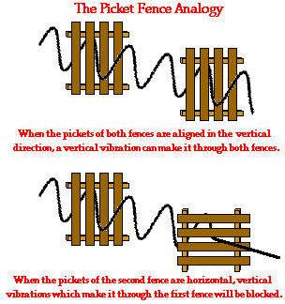

- True / False: A difference between a converging lens and a diverging lens is that a diverging lens is thicker in the middle than at the ends and a converging lens is thicker at the ends than in the middle.

- Film coatings can be used to protect human eyes from damaging light sources.
  - True
  - False

http://www.interactagram.com/physics/optics/refraction/
http://www.physicsclassroom.com/class/refln/Lesson-2/Ray-Diagrams-for-Plane-Mirrors
http://www.physicsclassroom.com/Class/refln/u13l1d.cfm - law of reflection
http://www.physicsclassroom.com/Class/refrn/U14l3c.cfm - critical angle
http://www.physicsclassroom.com/class/refrn/Lesson-4/Dispersion-of-Light-by-Prisms
http://www.physicsclassroom.com/class/refln/Lesson-3/The-Mirror-Equation
http://www.physicsclassroom.com/class/refln/Lesson-4/Reflection-and-Image-Formation-for-Convex-Mirrors
http://www.physicsclassroom.com/Class/refrn/U14L5a.cfm - lenses
http://www.physicsclassroom.com/class/refrn/Lesson-6/The-Anatomy-of-the-Eye
http://www.physicsclassroom.com/class/refrn/Lesson-6/The-Anatomy-of-the-Eye

