**February 20, 2016**

**Science Olympiad –Holt Invitational**

**Bio Processes**

**Name: ________________________________________**

**Name: ________________________________________**

**School and Team #: _____________________________________________________**

**Station A:**

**Lab Instruments**

Name the following instruments and what they are used for:

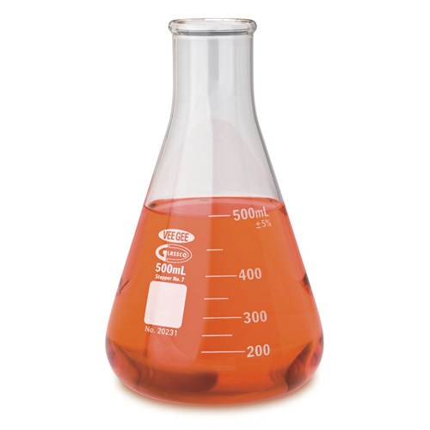

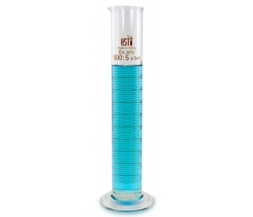

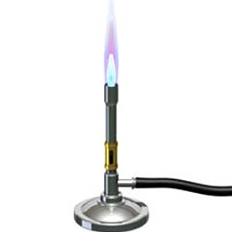

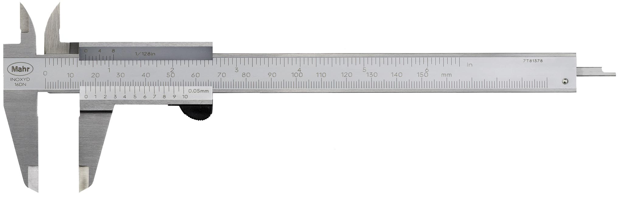

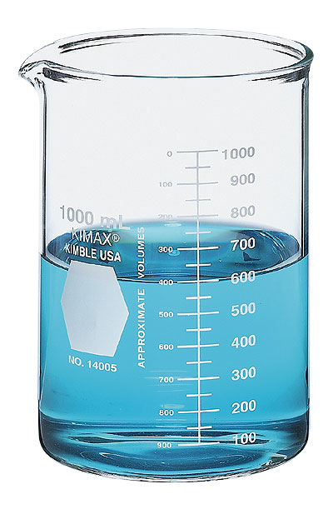

**Station B:**

**Measuring**

1. What is the volume of liquid in the container labeled A? Be sure to specify units.
2. What two measurements of an object can be used to determine its density?
3. What is the width of this piece of paper in millimeters?
4. What is the width of this piece of paper in meters?
5. What units of measurement would you use when measuring an object under a compound microscope?

**Station C: Graphical Analysis**

1. What is the dependent variable for graph A?
2. What is the independent variable for graph B?
3. Since chlorophyll-a is used to determine algae concentrations, what can you conclude about how phosphorus relates to algae?
   1. Phosphorus is a limiting nutrient for algae
   2. Phosphorus is an excess nutrient for algae
   3. Phosphorus is not needed for algal growth
   4. Phosphorus and algae are unrelated
4. What was the approximate concentration of chlorophyll-a in 2004?
5. Based on the graphs, you can conclude that:
   1. Chlorophyll-a and Phosphorus are the same thing
   2. Chlorophyll-a and Phosphorus are correlated
   3. Chlorophyll-a concentration decreases with increased phosphorus
   4. Chlorophyll-a and phosphorus are unrelated

**Station D: Population Density and Food Webs**

Study Area:



Which shape (Pacman, triangle, or plus sign) represents the following:

1. Primary Producers (autotrophs)
2. Primary Consumers
3. Secondary Consumers
4. Describe a potential food chain using real organisms based on your answers from the above question.

Using a ruler, measure the diagram of the study area to determine:

1. Perimeter (cm)
2. Area (cm2)
3. How many individual animals are within the study perimeter?
4. If this study area is a representation of a forest that is six times as large, how many individual animals would you expect in the entire forest?

**Station E:**

**Cells**

Diagram A: Diagram B:

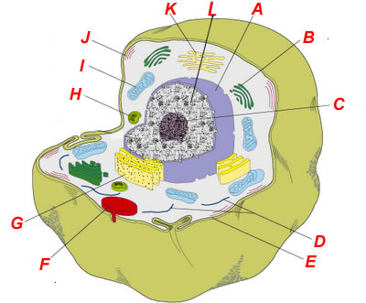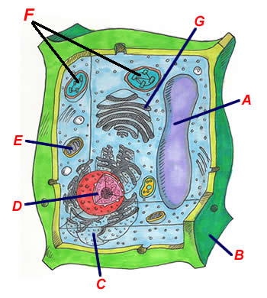

1. Which diagram is the plant cell?
2. Which is the animal cell?
3. Which letter corresponds to the **nucleus** in diagram B?
4. Which letter corresponds to the **vacuole** in diagram A?
5. Name one organelle that can be found in diagram A, but not in diagram B
6. Are these cells eukaryotic or prokaryotic? (Circle one)

**Station F: DNA Replication**

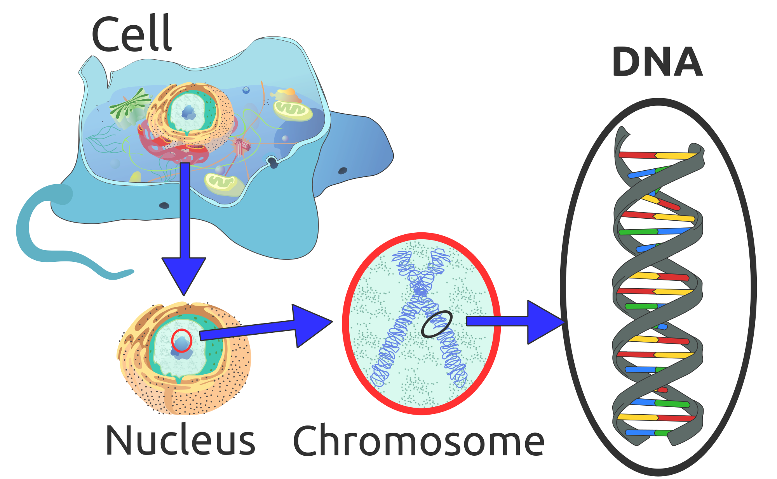

1. What is the DNA structure referred to (what is the structure called)?
2. Complete the following sequence: DNA 🡪 RNA 🡪 __________________
3. According to the following DNA sequence, what is complementary RNA sequence? ATTGCA 🡪
4. What type of cellular division results in 2 haploid cells with the exact same DNA as the parent cell?
5. Which of the following refers to the process of creating a complimentary RNA strand from a strand of DNA?
   1. Mutation
   2. Translation
   3. Replication
   4. Transcription

**Station G:** Food Webs

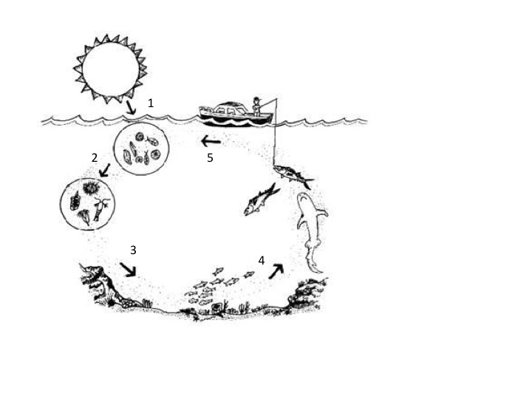

1. For what process do primary producers (autotrophs) need sunlight?
2. Which arrow represents the highest level of the food web?
3. As food travels up the food web, what happens to the efficiency of energy transfer?
   1. It increases
   2. It decreases
   3. It stays the same
   4. Which arrow corresponds with primary consumers?
4. Which arrow(s) could be considered predators?
5. If plants are considered autotrophs, then animals are considered ________________.

**Station H: Genetics**

In the following scenario, allele B is dominant to the recessive allele b. The dominant allele results in brown eyes, and the recessive allele results in green eyes.

1. Complete the following Punnet Square

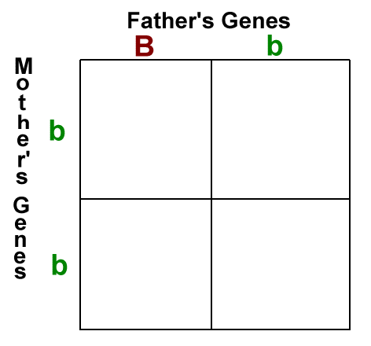

1. What is the ratio of brown-eyed offspring to green-eyed offspring?
2. Which possible genotype(s) would result in the brown-eyed phenotype?
3. How many pairs of chromosomes are present in human somatic cells?
4. What are the allele’s on the mother’s 23rd chromosome?

**Station I:**

**Observations vs Inferences**

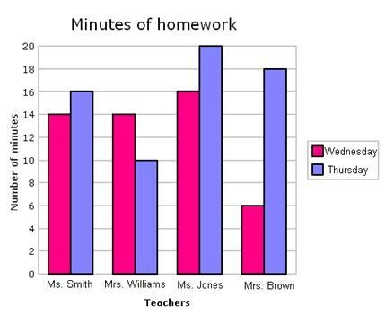

Based on the following graph which represents the amount of time students spend doing homework, determine if the following statements are:

A. A logical hypothesis according to the data

B. Illogical hypothesis or statement not supported by the data

C. Not a hypothesis, but a restatement of data

D. Inference based on the data

1. On average, students spend more time completing homework on Thursday as opposed to Wednesday.
2. Mrs. Williams assigns less homework on Thursday.
3. Students who spend more time on homework have better grades.
4. If the homework for all 4 teachers is due on Friday, then the majority of students wait until Thursday before completing their work.
5. Ms. Jones is the most demanding teacher because students in her class spend the most time doing homework.

**Station K: Water Cycle**

Complete the diagram using the following terms. One term per space will be used.

1. Evaporation
2. Accumulation
3. Condensation
4. Precipitation
5. Surface Runoff
6. Transpiration

