Holt Invitational Entomology B Test 2015 Answer Key
STATION # 1
Question A: Identify the order. Phasmatodea.
Question B: What is the common name of this insect? Giant Walking Stick.
Question C: How do these insects protect themselves from predators? Camouflage (answers may vary, look for key word “camouflage”).

STATION # 2
Question A: Identify the family. Vespidae.
Question B: What is the common name of this insect? Giant Hornet (Wasp).
Question C: What food do both the larvae and the adults eat, the only difference being that the larvae eat this food when it is first prechewed by the adults? Other Insects.

STATION # 3
Question A: Identify the family. Cicadidae.
Question B: What is the common name of this insect? Periodical Cicada.
Question C: How long can it take for this insect to complete development, turning from a nymph into an adult? 13-17 years.

STATION # 4
Question A: Identify the order. Odanata.
Question B: What is the common name of this insect? Widow Skimmer.
Question C: What gender is this specimen? Female.

STATION # 5
Question A: At a certain time, this insect is found almost exclusively on leaves, as depicted in stage 2. Why is this? The larva must feed extensively before forming a cocoon.
Question B: What is the purpose of the structure in stage 4? It protects the pupa as it turns into an adult.
Question C: The insects in stages 5 and 6 are both adults. Why do they differ so much in size? They are the male and female of the species.
STATION # 6
Question A: Identify the order. Orthoptera.
Question B: What is the common name of this insect? Grasshopper.
Question C: How many tarsi does this insect have? 6 (Tarsi is the plural of tarsus, meaning “foot”).

STATION # 7
Question A: Identify the order. Lepidoptera.
Question B: What is the common name of this insect? Monarch (Butterfly).
Question C: What other insect resembles this insect, and why? Viceroy (Butterfly). The Monarch is poisonous, so predators know not to eat it.

STATION # 8
Question A: Identify the family. Formicidae.
Question B: What is the common name of this insect? Spine Waisted Ant.
Question C: What type of relationship does this insect have with aphids? Symbiotic.

STATION # 9
Question A: Identify the order. Mantodea.
Question B: What is the common name of this insect? Praying mantis.
Question C: What type of fore limbs does this insect have? Raptorial (Half credit for predatory).

STATION # 10
Question A: Identify the order. Blattodea.
Question B: What is the common name of this insect? (American) Cockroach.
Question C: How far north could this insect hypothetically live? Antarctica or Greenland.

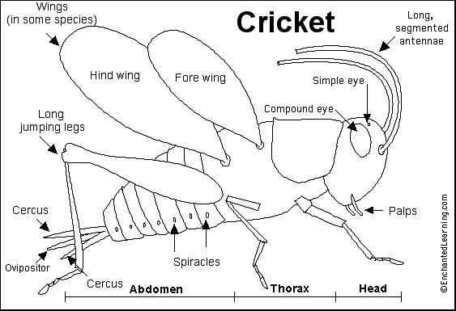
STATION # 12
A:
B:
C:
D:
G:
F:
E:

STATION # 11
Question A: Identify the order. Diptera.
Question B: What is the common name of this insect? Onion Fly.
Question C: What kind of an impact does this insect have on the environment? Negative, it’s a pest.

STATION # 13
Question A: Identify the family. Cerambycidae.
Question B: What is the common name of this insect? Long-horned Beetle.
Question C: The larvae of this insect are called “round headed bores”. What do the larvae bore into? Is this good or bad for the environment? Live trees, which is very bad for the environment.

STATION # 14
Question A: Identify the order. Hemiptera.
Question B: What is the common name of this insect? Shield bug, stink bug, or chust bug.
Question C: How does this insect protect itself from predators? By secreting a foul smelling liquid from glands between its first and second pair of legs.
STATION # 15
Question A: Identify the family. Scarabaeidae.
Question B: What is the common name of this insect? (Shiny green) Chafer beetle.
Question C: What is the name of the triangle shaped structure on the insect’s head? Horn.

STATION # 16
Question A: Identify the order. Grylloblattdea.
Question B: What is the common name of this insect? Ice insect.
Question C: These insects are named for their inability to survive in what type of environment? Warm.

