Holt Invitational 2017 Dynamic Planet

School: ______________________________ Team Color: __________________________
Competitor 1:__________________________ Competitor 2:__________________________

WRITE YOUR ANSWERS ON THE ANSWER SHEET!!!!

Holt High School
February 25th, 2017

Please complete the following activity and turn into the volunteers. WRITE YOUR ANSWERS ON YOUR ANSWER SHEET. You may write on the test, BUT IT WILL NOT BE GRADED.

- Label each part of the Earth’s Interior. (1pt ea.)
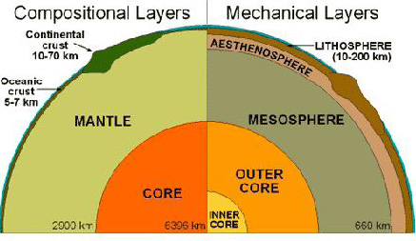
H
I
F
D
C
G
E
B
A
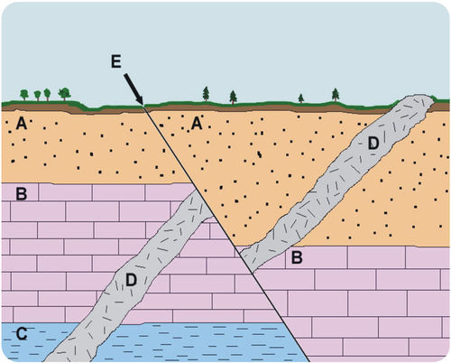
- Using the picture above what is the correct sequence? (2pts)
A: ABCDE B: CDEBA C: CBADE D: DEBDA

- Which scientist was responsible for bringing the “Theory of Continental Drift” into the public eye? (2pts)

- Which piece of evidence eventually became substantial evidence for the basis of today’s model of Plate Tectonics? (2pts)

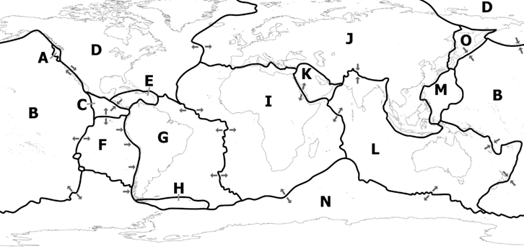
- Label each plate from the map above: (1 point each)
A: B: C:
D: E: F:
G: H: I:
J: K: L:
M: N: O:
- Which type of boundary exists between I and K? (1pt)
- Which type of boundary exists between O and B? (1pt)
- Which type of boundary exists between A and D? (1pt)
- The driving force behind plate tectonics is… (2pts)
- Explain the type of volcano a higher viscosity magma would create and why. (3pts)
- Explain the type of volcano a lower viscosity magma would create and why. (3pts)

- What is (are) the cause(s) of isostasy? (1pt for one answer 2 pts for more than one)

- The Mid-Ocean Ridge is found along what type of plate boundary? (1pt)

- The Richter scale increases by a magnitude of ______ times for each step up (example: How much more energy is released by a 6.0 earthquake than a 5.0 earthquake?) (1pt)

- The Oldest crust is found (2pt)

- What percentage of earthquakes occur along the Ring of Fire? (2pt)

- The cycle of opening and closing of ocean basins is the… (2pts)

- Give an approximate age of occurrence in mya (1pt for each answer within 50 mya)
    - Earth’s crust cools and solidifies
    - Huronian Ice age starts
    - Formation of Supercontinent Rodinia
    - Laurasia and Gondwana appear
    - Formation of Pangea
    - Formation of the Atlantic Ocean
    - Meteor Impact. Chicxulub crater, Yucatan, Mexico
    - Formation of the Himalayan mountains
- What type of forces create mountains? (1pt)
  - Tension
  - Compression
  - Horizontal
  - Convection
- The approximate rate of plate movement is (1pt)
  - Anywhere from 1-5 in/yr.
  - Anywhere from 1-5 cm/yr.
  - Anywhere from 1-5 mm/yr.
  - Anywhere from 1-5 ft. /yr.

- Magma with a high silica content tends to be: (1pt)
  - High Viscosity
  - High Volume
  - Low Viscosity
  - Low Volume
- A typical rate of seafloor spreading in the North Atlantic Ocean basin is (1pt)
  - 0.1 in/yr.
  - 1.5 in/yr.
  - 2 cm/yr.
  - 2 mm/yr.
  - 2 ft. /yr.
- Which of the following is NOT a force that impacts plate movement? (1pt)
  - Basal Drag
  - Isostasy
  - Slab Suction
  - Hypsometric Pressure
- 90% of the Earth’s crust (by volume) is composed of which of the following types of rock? (1pt)
  - Igneous
  - Basaltic
  - Sedimentary
  - Metamorphic
- The world’s largest Earthquake that was instrumentally documented was a ____ magnitude.
  - 7.8
  - 8.5
  - 8.8
  - 9.5
  - 9.8

- The largest Earthquake recorded along the San Andreas Fault in California was a ___ magnitude
  - 6.8
  - 7.4
  - 7.9
  - 8.3
  - 8.4
- Matching: On your answer sheet write the letter that corresponds to the name of the mountain range that was created. (1pt each)
  - These mountain ranges were created 480 mya
  - These mountain ranges were created 45 mya
  - These mountain ranges were created 32 to 23 mya
  - This volcanic arc started 37 mya
  - These mountains were formed 300 mya
- List the areas of the following continental margin (1pt ea.)
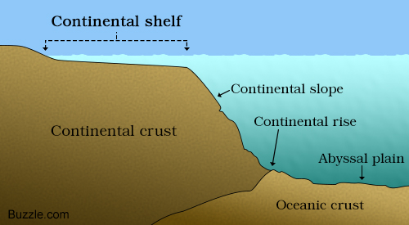
B
E
F
D
C
A

- Label each of the following faults.

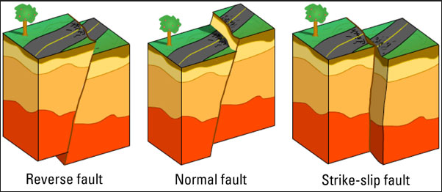
C
B
A

- Essay Question: Describe the creation of the North American Craton. Your answer will be graded on accuracy, use of geological terms, and completeness. (5pts)

Hawaii Plate Movement
- Using a ruler, measure the distance between the centers of the island in millimeters, write this in the table on your answer sheet.
- Convert that distance in millimeters into kilometers and record the data in the table on your answer sheet.
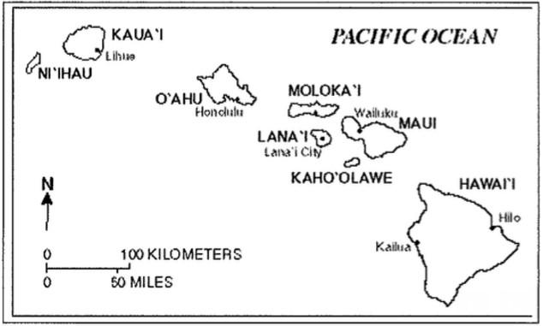
- Calculate the rate of plate movement for the last column on your data table.
- Hawaii is still forming, how many years ago was each island created? (1pt ea.)
  - Kaua’I
  - O’auhu
  - Moloka’I
  - Maui
  - Hawaii
- Based on the ages of the different Hawaiian Islands, which direction(s) is the pacific plate moving? (2pts) __________________________

