

*Team Name:___________________________*

*Student Names:______________________*

*________________________________________  
Team Number: ___________*

*_____/153 pts*

*RANK:*

**Station A: Indicators (32 points)**

* Must have goggles
* Maximum of 2*, non-programmable* calculators
* Round all measurements to the tenths place where applicable
* Answer all questions completely. Any blank questions will receive no points.
* Question 8 in Part 1 and question 2 in part 2 will be used as tiebreakers.
* Only one 8.5” X 11” note sheet may be used.
* Extra or non-qualifying items will be confiscated

February 21st, 2015

Holt High School

Division B Invitational

BIO-PROCESS LAB

*You are a lab technician at Sparrow Hospital. The clinic’s doctor has come in with 5 urine samples from different patients, all of them complaining of strange urine. Your job is to determine which patient could have which disease based on the chart below:*

|  |  |
| --- | --- |
| *Diabetes* | *The body does not produce enough insulin, a hormone that allows the body to process sugars. Symptoms include nerve damage and excess sugar in urine.* |
| *Excessive Vitamin Consumption* | *Tests have proven that taking Vitamin C supplements have drastically decreased one’s chances of developing kidney stones. Excess vitamins may become present in urine.* |
| *Proteinuria* | *Proteinuria (protein in the urine) is caused by a host of genetic disorders, where the body is unable to process protein. Symptoms include foaming urine and muscular atrophy.* |
| *Bartter’s Syndrome* | *Bartter’s Syndrome is a dysfunction in the nephrons of the kidneys. Excessive sodium chloride and potassium ions are unable to be processed in the body and are excreted by the kidneys.* |

*Using their urine samples and the indicators provided, mark the following table as positive or negative for each of the following substances’ presence in the urine. Also, write down what indicator is used to test for each substance. (0.5 points for each blank box)*

|  |  |  |  |  |
| --- | --- | --- | --- | --- |
| **Patient** | **Glucose** | **Vitamin C** | **Protein** | **Salt** |
| **Jack** |  | **–** |  | **–** |
| **Natalie** | **–** |  | **–** |  |
| **Olivia** |  | **–** |  | **–** |
| **Arynne** |  | **–** | **–** |  |
| **Avelino** | **–** |  |  | **–** |
| **Indicator** |  |  |  |  |

|  |  |  |  |  |  |
| --- | --- | --- | --- | --- | --- |
| **Patient** | **Diabetes** | **E.V.C.** | **Proteinuria** | **Bartter’s Syndrome** | **Healthy** |
| **Jack** |  |  |  |  |  |
| **Natalie** |  |  |  |  |  |
| **Olivia** |  |  |  |  |  |
| **Arynne** |  |  |  |  |  |
| **Avelino** |  |  |  |  |  |

(4 points for each correct diagnosis)

**Station B: Calculations & Measurements (20 points)**

Calculate/measure the following (2 points each):

**Density** of object A (g/cm3):



**Length** of object B (m):

**pH** of solution A:

**Temperature** of solution B (CO):

How many times denser is Mercury (7.6g/cm3) to object A? (3 points)



How many levels more acidic would a solution with a pH of 3 be than solution A? (3 points)

How much hotter would solution C be to boil water? (3 points)

A kilometer is 1,000 meters. Approximately how many object B’s would be a kilometer? (3 points)

**Station C: Microscopes (10 points):**

Place slide A under the microscope. Draw what you see here (5 points)

What is the answer to the question on slide B? (2 points)

What part of the body could slide C be from? (3 points)

**Station D: Dichotomous Keys (8 points)**

Using the provided Dichotomous key, find the names of the following insects (2 points each):

Insect W:

Insect X:

Insect Y:

Insect Z:

**Part Two - Written**

**Part 1: Interpreting data (14 points)**

A sample was taken from the large intestine of a victim in a case study of an illness. That sample was examined under a microscope, and many tiny circles were seen. Scientists then placed the circles into a petri dish to isolate them (get only the circles) and after observing the tiny circles growing and multiplying, collected many of them.

Next, the scientists injected the circles into 100 healthy rats. Here are the results:

Quantitative results:

Day 0: All rats alive.

Day 1: 4 dead rats, 96 alive.

Day 2: 56 dead rats, 44 alive.

Day 3: 97 dead rats, 3 alive.

Days 4-10: 97 dead rats, 3 alive.

Qualitative results:

Within a day, the rats' feces became watery. They also did not defecate in the normal places (corner of cage), so it appears that they had difficulty defecating. The feces also had a very strong, unpleasant odor. Furthermore, the rats became more motionless as their sickness became worse. The rats that survived showed similar symptoms, but seemed to recover after 5 days of illness. At that point, their feces firmed up and they began to show their normal levels of activity.

1. What is the difference between quantitative and qualitative data? (2 points)

2. Why is each important? (2 points)

3. List the steps of the scientific method. (0.5 points each)

1.

2.

3.

4.

5.

6.

7.

4. List a possible reason of why 1 to 2 of the rats survived. (3 points)

5. List the characteristics of life. (0.5 points)

1.

2.

3.

4.

5.

6.

7.

**Part 2: Microscopes: (23 points)**

1. How do you calculate the TOTAL magnification on a light microscope? (3 points)
2. Describe in detail how you view a specimen on high power. Start from the beginning of putting the slide on the microscope and ending with a focused image on high power. (10 points)
3. Match the numbers to the parts given (0.5 points each): (USE WORD LIST ON NEXT PAGE---- PUT LETTER NEXT TO NUMBER ON NEXT PAGE--------DO NOT DO ALL OF THESE)

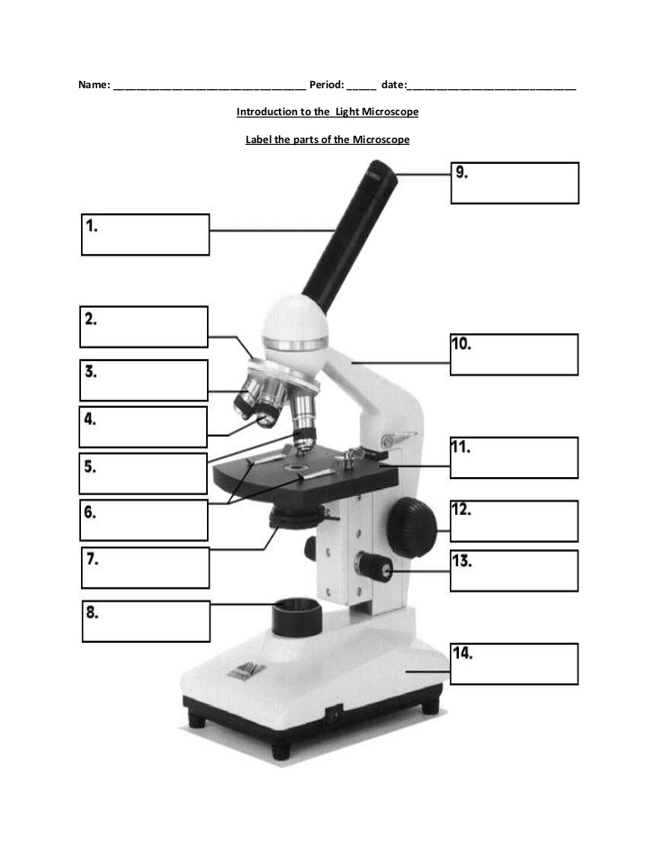

1. A. Eye piece

Only label these parts listed here:

B. Arm

3. C. Coarse adjustment knob

4. D. Medium power objective

E. Diaphragm

6. F. Revolving nosepiece

7. G. High power objective

H. Fine adjustment knob

I. Base

10. J. Light

K. Stage clips

12. L. Low power objective

M. Stage

14. N. Eyepiece Tube

Explain the function of 2, 7, and 5 (6 points)

**Part 3: Inferences and conclusions based upon data and observations. (20 points)**

There has been much talk in the media about which fast food restaurants are better for you. Students at Holt High School decided to test this out by eating fast food for lunch and dinner in one day. Each student had a different restaurant but all ate the same breakfast. Calculate the total calories, protein, fat, carbohydrate and fiber for the day. Compare those numbers to the recommended intake for a day.

**Breakfast – Taco Bell**

|  |  |  |  |  |  |
| --- | --- | --- | --- | --- | --- |
| *Food* | *Calories* | *Protein (g)* | *Fat (g)* | *Carbs (g)* | *Fiber (g)* |
| Orange Juice  (8 oz.) | 104 | 1 | 0.5 | 86.4 | 1 |
| Corn Flakes | 110 | 2.3 | 0.5 | 24 | 0.6 |
| Skim Milk | 80 | 7.8 | 0.6 | 10.6 | 0 |

Totals: 294 11.1 g 1.6 g 121 g 1.6 g

**Lunch - Taco Bell**

|  |  |  |  |  |  |
| --- | --- | --- | --- | --- | --- |
| *Food* | *Calories* | *Protein (g)* | *Fat (g)* | *Carbs (g)* | *Fiber (g)* |
| Fiesta Taco salad | 860 | 31 | 46 | 82 | 12 |
| Medium coke | 210 | 0 | 0 | 58 | 0 |

Totals: 1070 31 g 46 g 140 g 12 g

**Dinner - Taco Bell**

|  |  |  |  |  |  |
| --- | --- | --- | --- | --- | --- |
| *Food* | *Calories* | *Protein (g)* | *Fat (g)* | *Carbs (g)* | *Fiber (g)* |
| Beef Burrito supreme | 430 | 17 | 18 | 52 | 5 |
| Chips and cheese | 300 | 6 | 18 | 27 | 1 |
| Medium coke | 210 | 0 | 0 | 58 | 0 |

Totals: 940 23 g 36 g 137 g 6 g

**Snack - Taco Bell**

|  |  |  |  |  |  |
| --- | --- | --- | --- | --- | --- |
| *Food* | *Calories* | *Protein (g)* | *Fat (g)* | *Carbs (g)* | *Fiber (g)* |
| Cinnamon twists | 160 | 1 | 5 | 27 | 1 |

*Calories Protein (g) Fat (g) Carbs (g) Fiber (g)*

**Recommended:** 2200 66 73 319 22

**Daily totals:**

(1 point each)

1. Record your daily totals below the recommended values. Which nutrient did you have trouble reaching the daily recommended value? (5 points)
2. Was your meal balanced? (explain why or why not) (2 points)
3. Which nutrient was closest to the daily recommended? (2 points)
4. What single item could you eat again/ take away from the diet that would make the diet the most balanced? (2 points)
5. Write a conclusion about the diet and its nutritional values. Could someone live off of this? What is the best benefit of this meal? (5 points)

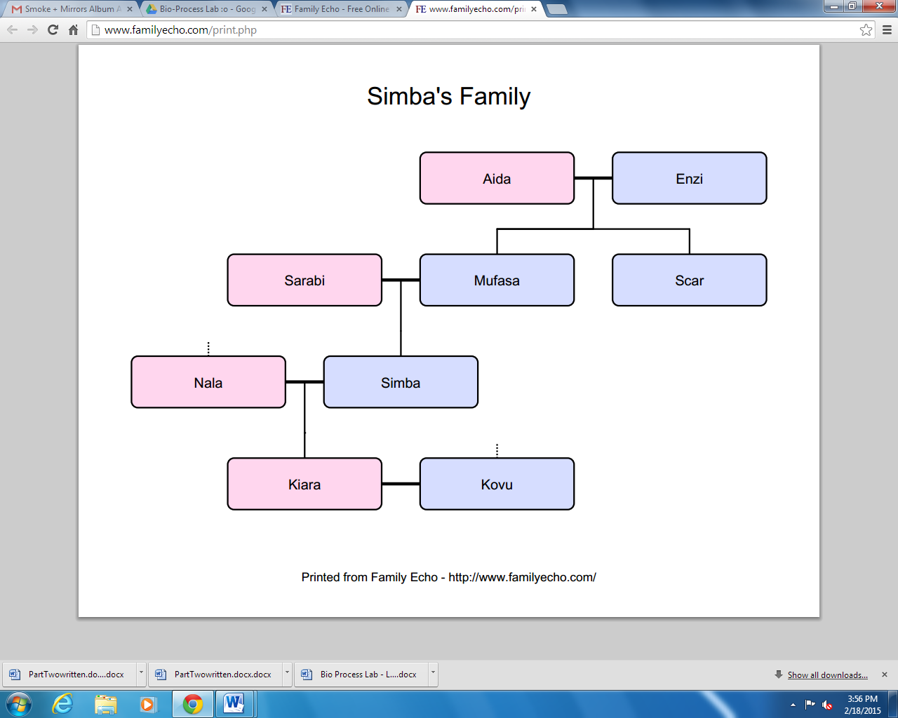**Part 4: Genetics (26 points)**

**Blood Types**

**B**-ida

**A+**

**B**

Aida

**O-**

**B+**

**A-**

Sarabi

**AB+**

**A+**

Nala

**O+**

**A-**

Kiara

Give each of the person’s genotypes (1 point each).

Aida:

Simba:

Scar:

Kovu:

Nala:

Using a Punnett Square, what is the probability Kiara and Kovu will have a child with type B blood (%)? (3 points)

If Nala and Simba were to have another child, what is the probability the child would have type O blood (%)? Explain. (2 points)

Nala is hunting for buffalo when she is attacked by a lion in another pride. She needs a blood transfusion. Who could safely donate their blood to Nala? Explain using your knowledge of antibodies and antigens. (6 points)

List the stages of Mitosis AND Draw them in order. Describe what happens in each phase (10 points)