ANATOMY AND PHYSIOLOGY TEST
Holt Invitational February 20, 2016

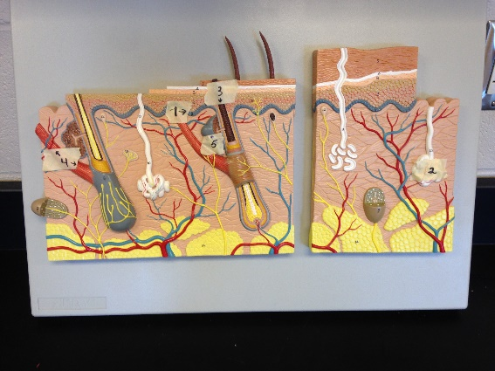
Station 1:
Name the structures of the skin:
- ______________
- ______________
- ______________
- ______________
- ______________

Station 2:
- What is the function of the skeletal system?
  - Support the body
  - Give the body shape
  - Work with muscles to move the body
  - All of the above

- What connects bones to other bones
  - Ligaments
  - Tendons
  - Both A&B
  - Neither A or B

- What are the name of the central channels in bone that contain blood and nerves?
  - Volkmann’s Canals
  - Haversian Canals
  - Lacunae
  - Bone channels

- What are the 2 types of bone structures?
  - Compact and Spongy
  - Hard and Soft
  - Osteoblast and Osteoclast
  - Long and Short

- What are the names of the 3 types of vertebrae?
1.)___________________
2.)___________________
3.)___________________
Station 3:
Name these Muscles:
- ___________________
- ___________________
- ___________________
- ___________________

15. What motion does the bicep femoris muscle allow you to do?

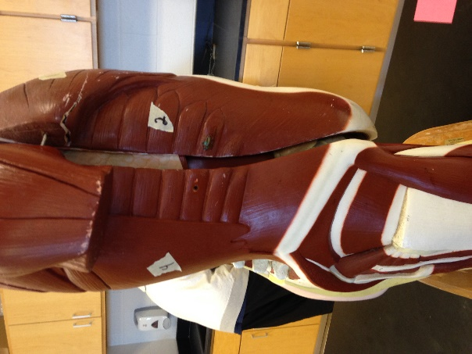
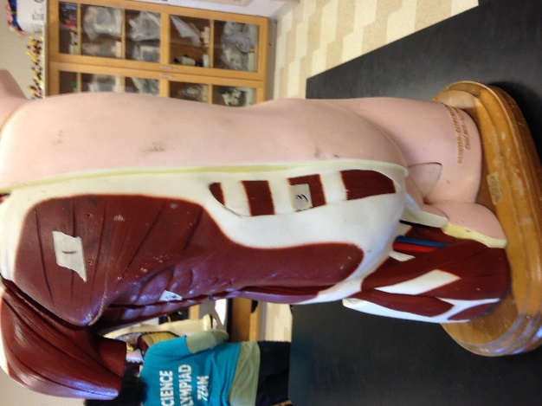

Station 4:
Name each example as one of the 3 main muscle types:
Muscle Types: SKELETAL SMOOTH CARDIAC
- ________16_________
- ________17_________
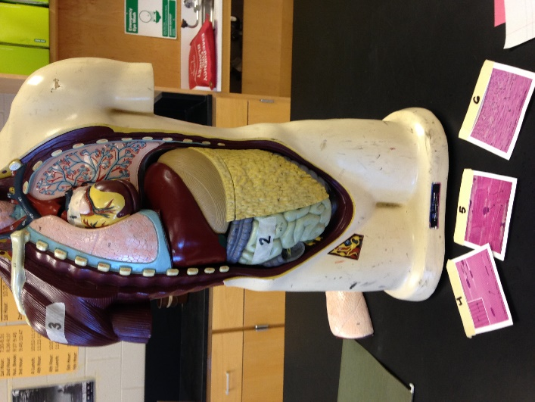
- ________18_________
- ________19_________
- ________20_________
- ________21_________

Station 5:
Identify these bones:
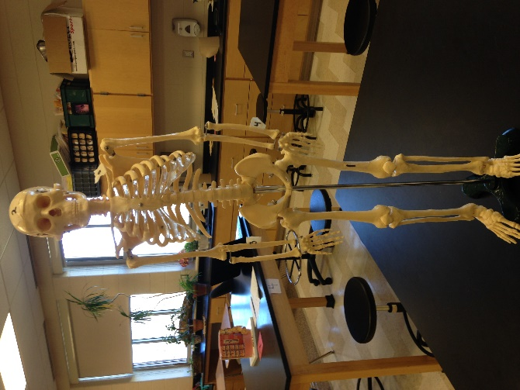
22.) ______Bone 1__________
23.) ______Bone 2__________
24.) ______Bone 3__________
25.) ______Bone 4__________
26.) ______Bone 5__________

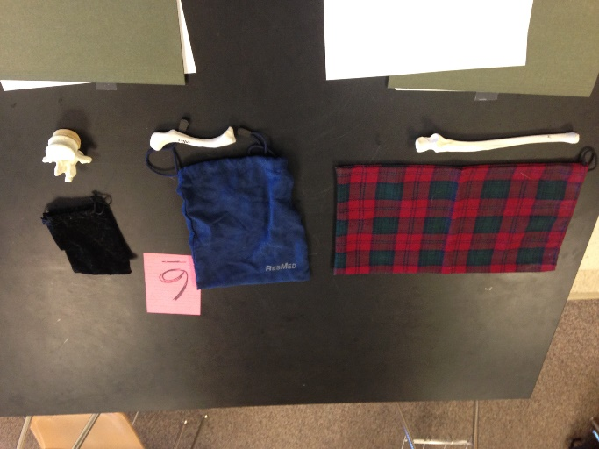
Station 6:
27.) Identify this bone (by touch) ___________________
28.) Where in the body would you find it?

29.) Identify this bone (by touch) ___________________
30.) Where in the body would you find it?

31.) Identify this bone (by touch) ___________________
32.) Where in the body would you find it?
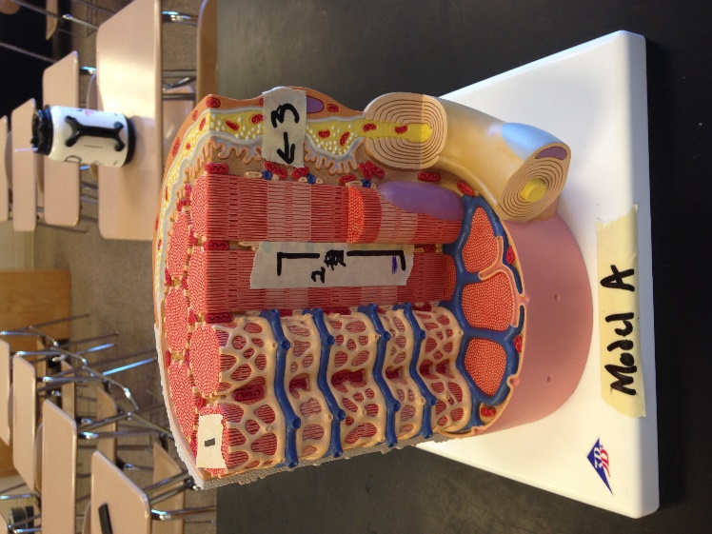
Station 7:
Label the following features:
1. ________33___________
2. _________34__________
3. _________35__________
36. Why does muscle contraction generate heat? (Short answer please)
Station 8:
37. VOID
38. If you had a skin cancer, would it be more likely to be
a. in the outermost layer of the epidermis
b. in the innermost layer of the epidermis
39. Why (must fit in blank)

40. What is the most common cause of skin cancer?

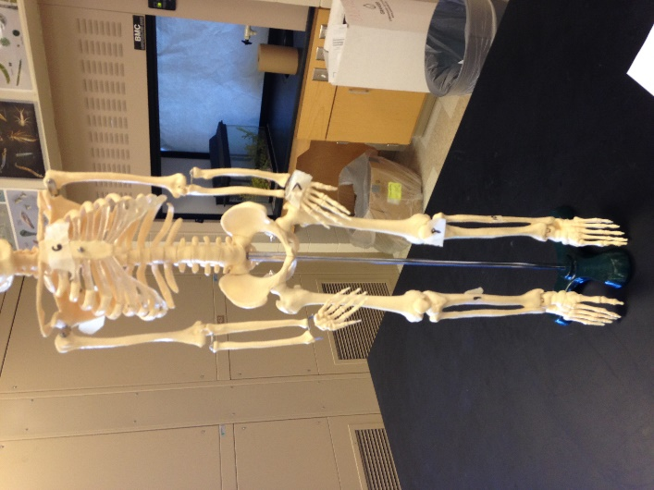
Station 9:
Identify these bones:
6. _________41__________
7. _________42__________
8. _________43__________
9. _________44__________
10. ________45___________
11. ________46___________

Station 10:
47. What is the outermost layer of skin?

- Which of the following is a protein that strengthens skin cells?
  - Melanin
  - Collagen
  - Keratin
  - Actin

- Which of the following is a protein responsible for skin color?
  - Melanin
  - Collagen
  - Keratin
  - Actin

- Which layer of the skin houses the majority of the accessory skin structures?
  - Hypodermis
  - Dermis
  - Epidermis
  - Subcutaneous Layer

