2016 Holt Invitational
Wind Power Test

School / Team Name (Please remember to indicate if you are an A or B team from your school if appropriate):

______________________________________

Team # _______

Student name(s):

___________________________________________ ___________________________________________

Low Speed Power Score _______ High Speed Power Score _______

Part I (Power) Score (50 pts) _________

Part II (Exam) Score (50 pts) ________

Total Score (100 pts) _________

Final Ranking: ______

(Tiebreaker: #1 – highest high speed voltage; #2 highest low speed voltage)

1) What orientation does the rotor shaft of a wind turbine need to be in in order to operate?

A) horizontal (parallel to the ground)

B) vertical (perpendicular to the ground)

C) the orientation depends on the design of the turbine

2) Name one advantage a turbine design with less blades has, and one advantage a design with more blades has.

3).What is the effect of a rotor with high solidity ( > 0.80)?

A) high speed high torque B) high speed low torque

C) low speed high torque D) low speed low torque

4) Some experimental wind turbines have incorporated an added structural design feature, called a/an _________, intended to increase the amount of wind passing through the blades.

5) Name the requested parts of the wind turbine in the picture below.
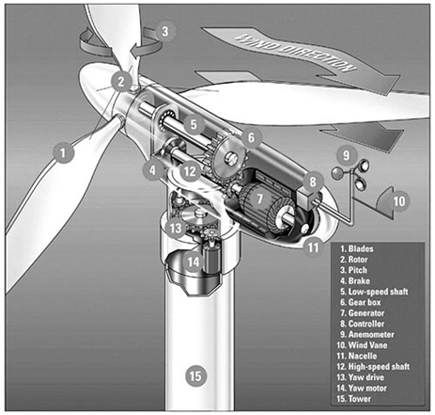

Part 1. _____________________

Part 2. _____________________

Part 5. _____________________

Part 7. _____________________

Part 9. _____________________

Part 10. _____________________

6) What percent of power in the U.S. is generated by renewable sources?

7) What is Betz’s Limit for wind turbines?

8) How is a turbine used to generate electricity?

9) Given a wind turbine with blade length 20 meters from the center and air speed 13 meters per second and air density of 1.1 kilogram per meter cubed, what power would it generate if it were 40% efficient? Express your answer in megawatts.

10) Using the diagram below, calculate the difference in one hour in joules of the energy difference between the Vestas V-90 2.0 MW turbine and the 1.8 MW turbine if the wind is a constant 12 m/s for that hour?

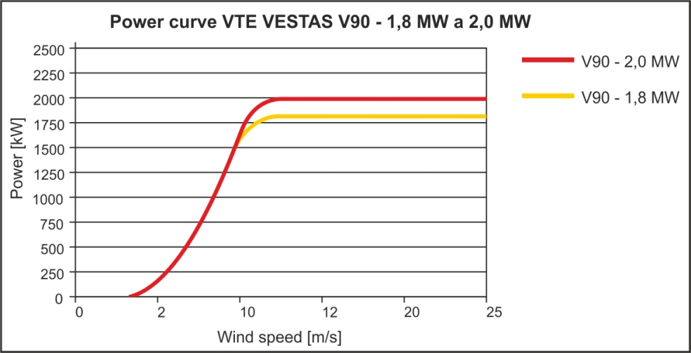

11) Give at least two reasons why energy, once it’s produced, might need to be stored instead of used.

12) Explain how pumping water can be used as a power storage mechanism.

13) Name 4 types of mechanical energy storage.
1. _________________________________ 2.___________________________________
3. _________________________________ 4. ___________________________________

14) Where (in general climate regions) is the use of heat storage to store wind energy most suitable?

15) At what time is energy most likely to be stored in an energy storage facility? (1pt)

A) 3 AM B) 9 AM C) 3 PM D) 9 PM

16. What does a transformer do?

17. All energy supposedly comes from the sun. Describe in detail how the energy from the sun would warm a cup of cocoa in your microwave if you used wind power.

18) If you ran a 60-watt bulb for 20 days and electricity costs are 12¢ per kWh, how much would it cost to run the bulb during that time?

19) A 40 km long electrical power line supplies 700 MW on a 400 KV line. The line has a resistance of 0.2 ohms per km. What is the voltage drop between the ends of the line?

20. In the above situation, how much power is lost in the line?

21) Windmills were first showcased at the Chicago World Fair in what year?

22) In the late 1990’s what percentage of California’s energy was generated by wind?

23) What orientation did the first windmills have, and what two main purposes were they used for?

24) What and where was the first windmills used in the U.S. to provide electricity to the local utility company?

25) Where were the first utility-scale wind energy conversion systems set up?

