Microbe Mission
2017 Holt High School Invitational
Division B

Team Name and Number __________________________________________________________

School Name____________________________________________________________________________

Student Names _______________________________________________________________________

Station I

Look into the microscopes

What is the blue part of the frog blood cell? (1 point)

2. Why does the frog blood cell have this blue part, and the red blood cell doesn’t? (hint: think about what a red blood cell does) (2 points)

3. Are red blood cells eukaryotic or prokaryotic? (1 point)

Station 2

Match the names in word bank to the labeled organelles (1 point each)

A._______________________________________
B._______________________________________
C._______________________________________
D.______________________________________
E.______________________________________
F.______________________________________

WORD BANK (not all words will be used, write name in provided blank)

Golgi Apparatus
Endoplasmic Reticulum (ER)
Nucleus
Mitochondria
Chloroplasts
Membrane
Centrioles
Ribosomes

Short Answer: What is the function of the mitochondria? (2 points)

Station 3

Match the names in word bank to the labeled organelles (1 point each)

A.________________________________________
B.________________________________________
C.________________________________________
D.________________________________________
E.________________________________________

WORD BANK (not all terms will be used)

Central Water Vacuole
Golgi Apparatus
Chloroplast
Cell Wall
Nucleus
Mitochondria
Ribosomes
Centrioles

Short Answer: What is the function of the chloroplast? What are 2 things that the chloroplast has that many of the other organelles do not? (3 points)

Station 4

Determine whether the statement is true or false by writing T or F in the blank (1 point each)

T/F Viruses are alive
T/F Bacteria are decomposers
T/F Schistosomiasis is caused by Parasitic worms
T/F Dengue Fever is treated by Penicillin
T/F Prions can only exist in the brain
T/F Thrush can be treated by unsweetened yogurt
T/F Transmission Electron Microscopes produce 3D images
T/F Electron microscopes cannot view live specimens
T/F 1 millimeter is equal to 1000 micrometers
T/F The Log Phase is where the cell population has peaked, and there is little cell growth

Station 5
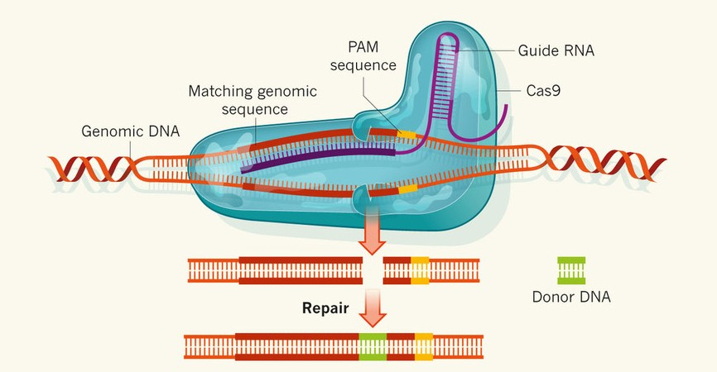

The CRISPR Cas9 protein can cut any sequence of DNA to which it is directed by a guide RNA. A Cas9-guide RNA complex can be introduced into any cell that needs to be altered. The repair enzymes can add or remove nucleotides.

How can CRISPR Cas9 be used in relation to diseases caused by mutations in DNA? (3 points)

Station 6

Answer the following questions based off of the microscope on the table

- What kind of microscope is this? (1 point)
- What is its maximum magnification? (1 point)
Name the labeled parts of the microscope and their functions using the terms from the word bank (1 point for correct, 1 point for correct function=2 points each)

3.__________________________________________________________________________
4.__________________________________________________________________________
5.__________________________________________________________________________
6.__________________________________________________________________________
7.__________________________________________________________________________
8.__________________________________________________________________________
9.__________________________________________________________________________

Station 7

Answer the following questions based off of the microscope on the table

- What kind of microscope is this? (1 point)
- What is the total magnification on the marked lens? (show work and explain) (1 point)

3. Circle which 3 specimens would be appropriate for this microscope (circle all correct answers) (1 point for each correct circle=3 points possible)

Frog
Virus
Prion
Insect
Bacteria
Sheep eye

Station 8
1. Plant Cells contain which of the following? (1 point)
Cell Walls
Chloroplasts
Central Water Vacuoles
All of the above

2. Which microbe is non living and contains genetic material? (1 point)
Protists
Virus
Bacteria
Prions

3. Which of these is not a type of protist? (1 point)
Plant-like protists
Algae-like protists
Animal-like protists
Fungi-like protists

4. MRSA is caused by (1 point)
Bacteria
Fungi
Parasitic worms
Viruses

5. Some bacteria produce a type of organic polymer known as PHA. How can PHA be used to our benefit? (1 point)
Used to make durable, biodegradable, plastics
Make Ethanol
Both A and B
None of the above
6. What is bioremediation? (1 point)
Bringing people back from dead
6 Using bacteria to clean up oil spills
Making ethanol
The difference between microbes

7. What is a viable cell? (1 point)
A dead cell
A cell without genetic material
A living cell
Invisible cell

8. What is yeast? (1 point)
Bacteria
Protist
Plant
Fungus

9. What makes archaea different from eubacteria? (1 point)
Archaea divide through mitosis and eubacteria divide through meiosis
Eubacteria are derived from eukaryotes
Archaea can survive in extreme conditions
Archaea are derived from eukaryotes

10. Which of the following statements about this picture is true? (1 point)
It can reproduce on its own
It is a living microbe
It is pyrogenic
It does the lytic cycle

Station 9
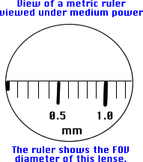
- What is the approximate size of this microbe in micrometers (μm)? (1 point)

- What is the approximate size of the field of view in micrometers (μm)? (1 point)

- What are the names of the hair like structures on the microbe above? What are they used for? (2 points)

Station 10
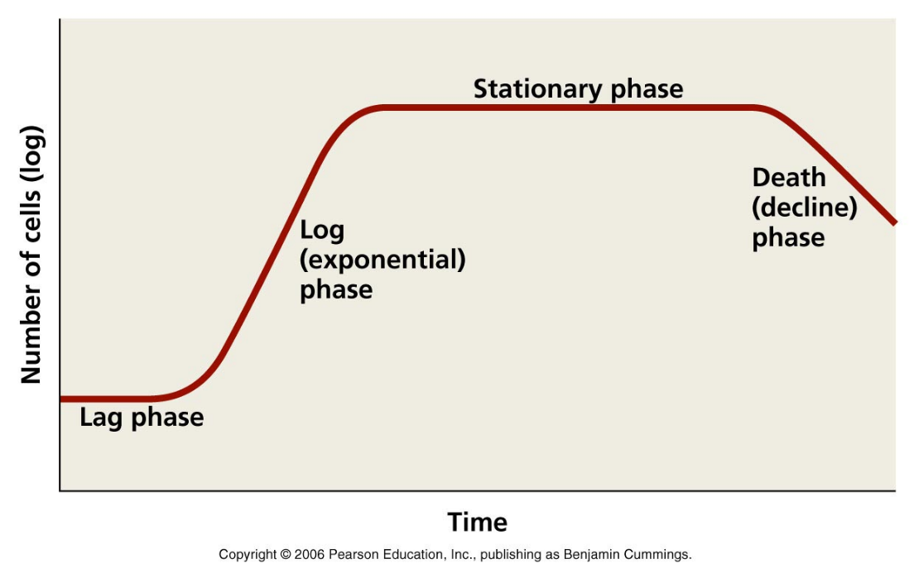
- Which phase has the most mitosis occurring? (1 point)

- Which phase has the highest number of viable cells? (1 point)

- Which phase do we see a sharp increase of non viable cells? (1 point)

- There are currently 500 bacteria in a petri dish. They are in the stationary phase. During the log phase, the population doubled every minute. How many bacteria would we expect to see after an hour if the cells remain in their current phase? (2 points)

Station 11

Write next to each disease the type of microbe that causes it (Bacteria, virus, protozoa/algae, prion, parasitic worms, fungus) (1 point each)

Botulism ___________________________________________
Dental Caries _________________________________________
Paralytic Shellfish poisoning ___________________________________________
West Nile Fever _______________________________________
Cryptosporidiosis ___________________________________________
AIDS___________________________________________
Ergotism ___________________________________________
Potato Blight ___________________________________________

9. What body symptom does polio affect? (2 points)

10. A child has swelling in their salivary glands, causing soreness and pain while swallowing. It is easily preventable by vaccine. What disease do they have? (2 points)

Station 12

- A potted plant is sitting in a window sill. Plants do photosynthesis. What 3 things are needed for photosynthesis to occur? (3 points)

- What is produced during cellular respiration? (2 points)

- What is purpose of photosynthesis? (1 point)

- What is the name of the type of cellular respiration the requires oxygen? (2 points)

- What is released into the atmosphere during photosynthesis? (1 point)

Station 13
Write at least 1 similarity and 2 differences between Prions and Viruses (1 point for each similarity/difference= 3 points)

Write at least 2 similarities and 1 difference between Eubacteria and Archaea (3 points)

Constructive Response

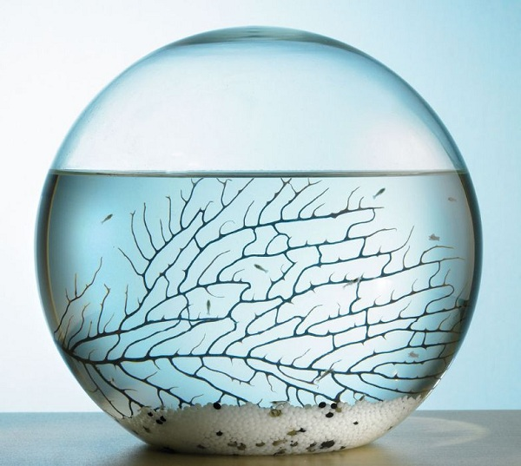
This is an Ecosphere. It is an enclosed ecosystem. Ecospheres are placed on window sills and can last for years. In the typical Ecosphere, you will find Brine shrimp, which is an animal, algae, and bacteria. Describe how these organisms interact to maintain a stable environment and survive for years. (5 points)

