Station One: Ocean Floor Topography
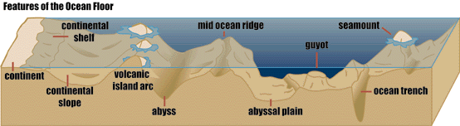
2.
5.
4.
3.
1.
For 1-5, match the following terms to the above features and write corresponding letter down on your answer sheet. (1 Pt each) If you are unclear as to what number is referring to what feature, feel free to ask the test proctor.
A.) Continental Shelf B.) Mid Ocean Ridge C.) Mid Ocean Valley D.) Guyot

E.) Seamount F.) Island G.) Abyssal Hill H.) Abyssal Trench I.) Subduction Zone

6.) What is a submarine canyon and what typically creates them? (2 points)

7.) What takes place in the Zone of Subduction? (1 point and TIEBREAKER)

Station Two: Coral Reef Formation

For 8-10, write the stage of coral reef formation that corresponds to the below picture.
(1 pt each)
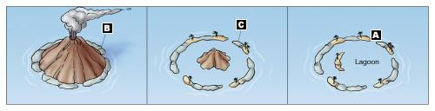
8.) Formation B:
9.) Formation C:
10.) Formation A:
11.) What is the ideal range of pH for coral reef formation? (1 pt)
12.) In what type of waters do Coral Reefs thrive in? (1 pt)
A.) Nutrient Poor waters B.) Nutrient Rich waters
C.) Acidic Waters D.) Cold Waters

Station Three: Tides
Figure A
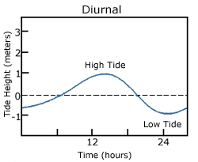
13.) Figure A represents a _______ tidal pattern. (1 pt)
14.) Figure B represents a _______ tidal pattern. (1 pt)
15.) Figure C represents a _______ tidal pattern. (1 pt)
Figure B
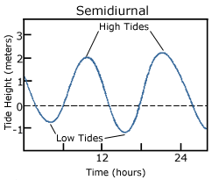

Figure C
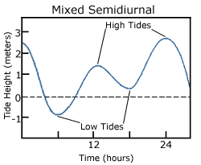

(16 and 17 may be used as a tiebreaker)
16.) A Neap Tide is ______ and occurs ______. (1 pt)

A.) The lowest tidal range; when the sun moon and earth form a 90 degree angle
B.) The lowest tidal range; when the sun moon and earth are aligned
C.) The highest tidal range; when the sun moon and earth are aligned
D.) The highest tidal range; when the sun moon and earth form a 90 degree angle.

17.) A Spring tide is _____ and occurs _______. (1 pt)

A.) The lowest tidal range; when the sun moon and earth are aligned
B.) The lowest tidal range; when the sun moon and earth form a 90 degree angle
C.) The highest tidal range; when the sun moon and earth are aligned
D.) The highest tidal range; when the sun moon and earth form a 90 degree angle.

Station Four: Waves
(1 pt each)

18.) What impacts wave height?
A.) fetch, wind speed, wind duration B.) fetch, temperature, wind speed
C.) fetch, wind duration, temperature D.) temperature, O2 levels, Salinity

19.) How do water particles move inside of a wave (movement of energy)?
A.) In a back and forth motion B.) In a circular motion
C.) In a rectangular motion D.) Not at all

20.) If the (height: length) ratio exceeds _____, the wave will break.
A.) 1:4 B.) 1:11
C.) 1:3 D.) 1:7

21.) A wave also commonly referred to as a “ripple” that travels along the phase boundary of a liquid is a:
A.) Seiche Wave B.) Breaker Wave
C.) Capillary Wave D.) Kelvin Wave

22.) A standing wave that oscillates in a body of water is called a ( I.E water sloshing in a bathtub):
A.) Seiche Wave B.) Breaker Wave
C.) Capillary Wave D.) Kelvin Wave

23.) A wave that collapses on itself is called a:
A.) Seiche Wave B.) Breaker Wave
C.) Capillary Wave D.) Kelvin Wave

Station Five: Salinity

24.) The average open ocean salinity is: (1 pt)
A.) 2% B.) 5%
C.) 35 ppt D.) 60 ppt

For 25-28, given the situation, respond as to how it would affect the salinity of the water. (1 pt each and number correct can be used as a TIEBREAKER)

25.) An icecap melts into the surrounding water

26.) The temperature in the area is at an all-time high and there has been little precipitation.

27.) A river empties out into the ocean

28.) Water freezes and an iceberg forms

29.) What is brackish water and where is it commonly found? (2 pts)

SAL.) If the Chlorinity of a sample of water is 20.2 ppt, what is the salinity (in ppt)? Show work on your work sheet. (2 pt)

Station Six: Layers of the Ocean

30.) Name the five pelagic layers of the ocean and order them from shallowest to deepest.
(10 pts + TIEBREAKER)

31.) What is the Thermocline? (1 pt)

32.) What is the Halocline? (1 pt)

33.) What is the Pycnocline? (1 pt)

Station Seven: Ocean Tools

Match the following pictures of oceanic instruments to their name in the word bank.
(1 pt each)

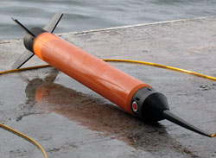
36.
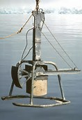 35.
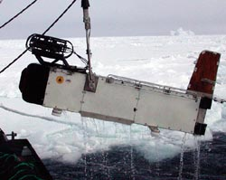
34.

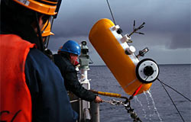
37.

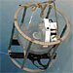 38.

Word Bank:
- Zooplankton sampler
- Marine Magnetometer
- Moored Profiler
- Box Corer
- BioMapper II

Station Eight: Estuaries

39.) An estuary contains ______ water and is a very ______ ecosystem. (1 pt)
A.) Fresh; productive B.) Salt and Fresh; unproductive
C.) Salt and fresh; productive D.) Fresh; unproductive

For 40-43, write (on your answer sheet) the type of estuary mixing that corresponds to the following figures. (1 pt ech)

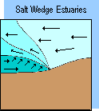
41.
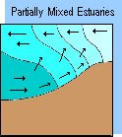
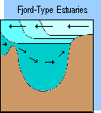
40.
42.

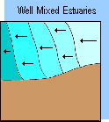
43.

44.) What type of geologically classified estuary is shallow and separated from the open ocean by sand bars deposited parallel to the coast. (1 pt)
A.) Bar-Built B.) Tectonic
C.) Coastal Plain D.) None of the above

Station Nine: Currents

45.) What is the main driving force of surface currents?
A.) Wind B.) Temperature Differences
C.) Marine life movement D.) Salinity

46.) What cause surface currents to curve (or deflect)?
A.) Ekman Spiral B.) Coriolis Effect
C.) Salinity D.) Density

48.) What type of current(s) does the following picture represent, and then briefly describe the process that takes place. (3 pt)

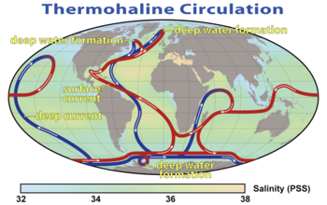

49.) A large circular moving loop of interconnected surface currents is called a:
A.) Thermohaline Current B.) Tombolo
C.) Gyre D.) Trade wind current

Station Ten: The topic is for you to figure out
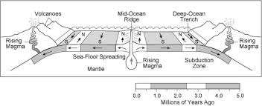

Each question refers to the above figure, write the answer on your answer document.

50.) The Above figure shows reversals in magnetic polarity of the earth, what is the name of the process that results in each segment of crust having a different polarity. (1 pt)

51.) Where is the ocean crust the oldest? Where is the crust the youngest? (2 pt)

52.) What is occurring at the mid ocean ridge? (1 pt)

53.) Where is the crust destroyed? (1 pt)

54.) What tends to form above zones of subduction? (1 pt)

55.) What is sea floor spreading, and what is created during this process? (2 pt)

Station Eleven: Misc.

56.) Which has an impact on the density of water? (1 pt)
A.) Temperature B.) Salinity
C.) Pressure D.) All of the above

57.) At what temperature is water the densest? (1 pt)
A.) 0°C B.) -15°C
C.) 4°C D.) 32°C

58.) In the ocean, as depth increases, Oxygen levels ________. (1 pt)
A.) Increase B.) Decrease C.) Remain constant

59.) Explain Destructive Interference in waves. (1 pt)

60.) At a zone of subduction, what type of tectonic plate boundary is usually found? (1 pt)
A.) Convergent B.) Divergent C.) Transverse D.) Paper

61.) What is upwelling? Does it result in productive or unproductive waters? (2 pt)

62.) List the primary energy inputs and outputs into the ocean. (4 pt and TIEBREAKER)

