

Holt Division B Science Olympiad tournament 2017

Hovercraft



February 25, 2017

[Company name]

[Company address]

.

# Hovercraft

*Please work quietly with your partner to complete this exam.*

*Please speak only to your partner.*

*Sorry, you may not talk to anyone else while working on this exam.*

***Multiple Choice***

*Clearly indicate the best answer for each question on both the test booklet – AND – on the bubble sheet provided.*

*Lowest time period to complete the exam and submit will be used in the case of a tie exam score.*

*\*\*\* Please be prepared to use BOTH 9.8 m/sec2 – and – 10 m/sec2 for the acceleration of gravity here on Earth \*\*\**

Please work quietly with your partner to complete this exam

### What is the SI unit of Weight? (1 point)

a. joule. c. meter.

b. kilogram. d. newton.

### Who invented the hovercraft and when? (2 point/s)

### What are principles behind hovercraft? (2 point/s)

### What is weight in N (Newton) of 100 pounds mass. (Choose closest) (2 point/s)

a. 400 m/(s^2). c. 500 m/(s^2).

b. 300 m/(s^2) d. 444 m/(s^2).

### A car's velocity changes from +2 m/s to +10 m/s in 4 seconds. What is its acceleration? (2 point/s)

a. 3 m/(s^2). c. 4 m/(s^2).

b. 2 m/(s^2) d. None of the above

### What is the acceleration experienced due to gravity on moon? (2 point/s)

a. 1.68 m/(s^2). c. 1.63 m/(s^2).

b. 1.5 m/(s^2) d. None of the above

### What is the acceleration produced by a force of 225N on a mass of 450?

### (1 point/s)

a. .5 m/(s^2). c. 2 m/(s^2).

b. 5 m/(s^2) d. .2 m/(s^2).

### Given a force of 88n and an acceleration of 4m/s^2 what is the mass?

(1 point/s)

### Calculate acceleration from following data (2 point/s)

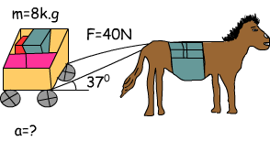

### Calculate the speed and velocity of the man moving 45m to the north, and 36m to the south in 27 seconds. (3 point/s)

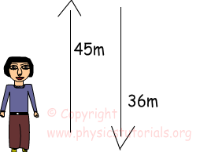

a. 3 m/s 3 m/s c. 3 m/s, 0.33 m/s.

b. 3 m/s, 0.33 m/(s^2) d. 3 m/(s^2), 0.33 m/(s^2)

### For years, space travel was believed to be impossible because there was nothing that rockets could push off of in space in order to provide the propulsion necessary to accelerate. This inability of a rocket to provide propulsion is because ... (1 point/s)

a. ... space is void of air so the rockets have nothing to push off of.

b. ... gravity is absent in space.

c. ... space is void of air and so there is no air resistance in space.

d. ... nonsense! Rockets do accelerate in space and have been able to do so for a long time.

### Which of the following statement best explains why the runner is able to accelerate forward when starting to run? (2 point/s)



1. The foot not touching the ground propels the entire body as it swings forward.
2. No acceleration takes place. Runners are always at a fixed velocity.
3. The striking foot pushes backward against the ground. The friction with the ground provides an equal and opposite force forward.
4. As one leg moves backward, it provides an equal and opposite force for the other foot to move forward.

### Determine the momentum of a 360,000-kg passenger plane taxiing down a runway at 1.5 m/s. (2 point/s)

a. 3.6 x 105 kg•m/s c. 1.5 x 105 kg•m/s.

b. 5.4 x 105 kg•m/s d. 2.7 x 105 Pound •m/s

### A bicycle has a momentum of 24 kg•m/s. What momentum would the bicycle have if it had … (3 point/s)

**a.** … twice the mass and was moving at the same speed?  
**b.** … the same mass and was moving with twice the speed?  
**c.** … one-half the mass and was moving with twice the speed?  
**d.** … the same mass and was moving with one-half the speed?  
**e.** … three times the mass and was moving with one-half the speed?  
**f.** … three times the mass and was moving with twice the speed?

### Suppose the entire population of the world gathers in one spot and, at the sounding of a prearranged signal, everyone jumps up. While all the people are in the air, does Earth gain momentum in the opposite direction? (2 point/s)

1. No; the inertial mass of Earth is so large that the planet's change in motion is imperceptible.
2. Yes; because of its much larger inertial mass, however, the change in momentum of Earth is much less than that of all the jumping people.
3. Yes; Earth recoils, like a rifle firing a bullet, with a change in momentum equal to and opposite that of the people.
4. It depends.

### Consider two carts, of masses m and 2m, at rest on an air track. If you push first one cart for 3 s and then the other for the same length of time, exerting equal force on each, the momentum of the light cart is (2 point/s)

1. four times b. twice
2. equal to d. one-half
3. one-quarter

the momentum of the heavy cart.

### A car moved 60 km East and 90 km West. What is the displacement? (2 point/s)

a: 30 km West b: 60 km West

c: 30 km East d: 150 km

### If a car has a constant acceleration of 4 m/s2, starting from rest, how far has it traveled by the time it reaches the speed of 40 m/s? (2 point/s)

a: 50 m b: 100 m

c: 200 m d: 400 m

### A car starts from rest and accelerates uniformly over a time of 5.21 seconds for a distance of 110 m. Determine the acceleration of the car. (3 point/s)

### A car traveling at 22.4 m/s skids to a stop in 2.55 s. Determine the skidding distance of the car (assume uniform acceleration). (3 point/s)

### A hiker is at the bottom of a canyon facing the canyon wall closest to her. She is 280.5 meters from the wall and the sound of her voice travels at 340 m/s at that location. How long after she shouts will she hear her echo? (Be careful to consider why echoes happen.) (2 point/s)

### Light travels with a speed of 3.00 x 105 km/s. How long will it take light from a laser to travel to the moon (where it is reflected by a mirror) and back to Earth? The moon is 3.84 x 105 km away from the Earth. (3 point/s)

### A cross-country racecar driver sets out on a 100 km race. At the halfway marker (50 km), her pit crew radios that she has averages only 80 km/h. How fast must she drive over the remaining distance in order to average 100 km/h for the entire race? (2 point/s)

a: 50 km/h b: 100 m /h

c: 133 km/h d: 150 km/h

### A supersonic jet travels once around the earth at an average speed of 1.6 x 103 km/h. Its orbital radius is 6.5 x 103 km. How many hours does the trip take? (Chose closest)

### (3 point/s)

a: 50 h b: 100 m /h

c: 30 h d: 26 h

### Examine this graph carefully to answer questions 1 and 2. (10 point/s)

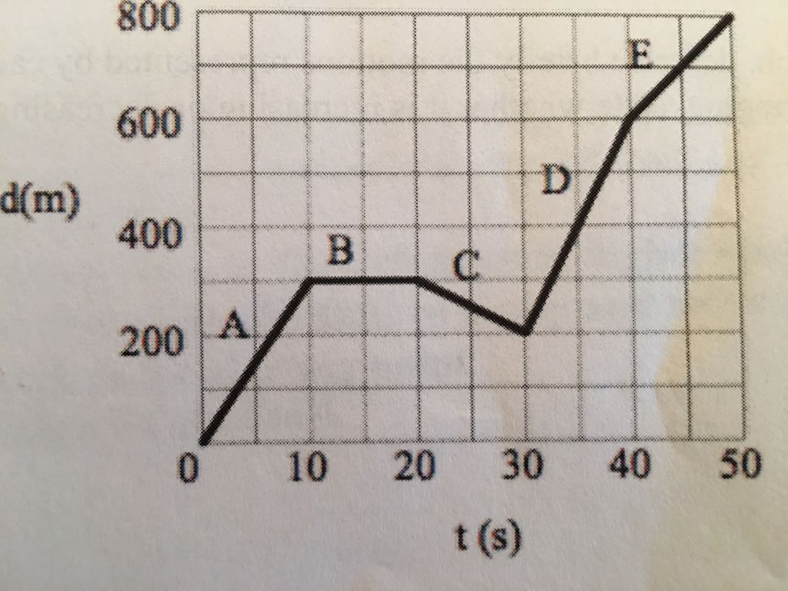

How far is the truck from its starting point after?

(a) 10 s

(b) 15 s

(c) 30 s

(d) 43 s

(e) 50 s

2. What is the truck’s velocity in each of the intervals A through E?

A

B

C

D

E