Green Generation
Holt High School Division B Science Olympiad Invitational
2/21/2015

Team Name: _____________________________
Team Number: ___________________________
School Name: ____________________________
Raw Scores: _____________________________
Any tie breakers?: _________________________
Rank: __________________________________

MULTIPLE CHOICE 1 point each

- Devin has a fish tank with guppies. Every day, Devin feeds his fish one-half teaspoon of fish food. The average guppy population in his aquarium over four months is 38 guppies. Devin goes on a four-month vacation and asks Nathan to take care of his tank. Accidently, Nathan starts to give the guppies one teaspoon of fish food each day. After the vacation, the average population is 53 guppies. Which of the following statements is true?
  - The size of the aquarium is a limiting factor.
  - Fish food is a limiting factor.
  - As long as Devin and Nathan keep adding more food, the guppy population will grow.
  - The guppy population has reached carrying capacity.
  - Guppies are super cool fish.

- Which of the following is not true of the intertidal zone in an estuary?
  - The intertidal zone is the area between high and low tide, so it is not always wet or always dry.
  - Some organisms carve holes into the rocks and hide in these holes during tidal changes.
  - Mussels use byssal threads to hold onto rocks and prevent themselves from being pulled off the tides
  - Nekton are always found in the intertidal zone during both high and low tides
  - All of the above are true

- Which of the following process(es) in the water cycle is/are affected by vegetation?
- Transpiration II. Interception III. Runoff
  - I only
  - I & II only
  - I & III only
  - I, II & III

- Which of the following is not true regarding the conversion of forms within the carbon cycle?
  - Respiration; oxygen to carbon dioxide in all organisms
  - Photosynthesis; carbon dioxide to oxygen in autotrophic organisms
  - Combustion; release of methane from organic compounds
  - Thermohaline circulation; movement of carbon dioxide within the ocean
  - All of the above are true.

- What is the maximum number of a species that can be sustained in an ecosystem ?
  - The carrying capacity
  - An ecotone
  - The upward curve of a population graph.
  - Natural selection

- A community Which of the following fishing techniques is most damaging to ocean bottom ecosystem? The carrying capacity
  - Trawling
  - The use of drfit nets
  - Long lines
  - Purse-seine

- Fish farming Sustainability strategies include __________
  - Minimizing energy consumption
  - Using alternative energy sources
  - Reducing, reusing and recycling
  - Developing green technology and chemistry
  - All of the above

- Acid rain is produced when both naturally occurring and man-made and _________ react with water, oxygen and other chemicals in the atmosphere.
  - Methane and carbon dioxide
  - Sulfur dioxide and nitrogen oxides
  - Ozone and Chloroflurocarbons
  - Nitrous oxide and carbon monoxide

- According to Guinness world records, which country has worst marine pollution? _______
  - China.
  - India
  - Japan
  - United States of America

- The curve shown below is an example of:
  - Exponential growth
  - Logistic growth
  - Dynamic growth
  - None of the above
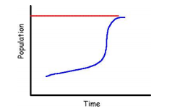

FILL IN THE BLANKS1 point each

- The process of a body of water receiving excess ammonia which stimulates algae growth is called ____________________

- The change of water from a gas to a liquid is known as _____ ______________

- The process in which water becomes a vapor in the atmosphere is known as_______________

- Water stored in aquifers is known as ______________________

- Strategy that uses microbes, plants or enzymes from these communities to detoxify pollutant contamination is _________________________

- Spontaneous flow of heat from warmer to cooler bodies is called ________________.

- Name the two types of autotrophs _______________________________ and
_________________________________

TRUE OR FALSE1 point each

- ______________ fire a major factor in maintaining biome

- ______________ 98% of water on earth is salt water in the ocean.

- ______________ over fishing of a species can affect tropic both above and below that species.

- ______________ available land will decrease if global warming continues.

- ______________ population with low genetic diversity survive better than populations with high genetic diversity.

- ______________ the most productive terrestrial ecosystems are tropical savannas.

- ______________ phosphorus is essential for plant and animal growth

Q&A1 point each

- Name the largest undeveloped mangrove ecosystem in the United States

- Are the fresh-salt mixing areas of the Great Salt Lake in Utah (or other salt lakes) considered to be "estuaries"?

- Why or why not?

- What is other term of primary producers?

- What is the largest dead zone in the united states?

- Where is largest hole in ozone located?

- Explain zone of Saturation?

- What are Artesians wells?

- Give 2 major difference between R strategists and K strategists.

- What is Smog?

- When did Fukushim daiichi occur?

- What lake is formed by Hoover Dam?

- Define the difference between point source and non-point source pollution?

- What is vermicomposting?

- Draw a trophic pyramid with 4 layers and label each layer with the trophic level it represents (do not include decomposers/detritivores as a level in the diagram) 4 points

- Draw the Nitrogen Cycle 4 points

- What are the 3 R’s of recycling? And what does the symbol represent? 1 point

- Insert the percentages in the greenhouse effect diagram: (Allow a +/-5% error) 3points

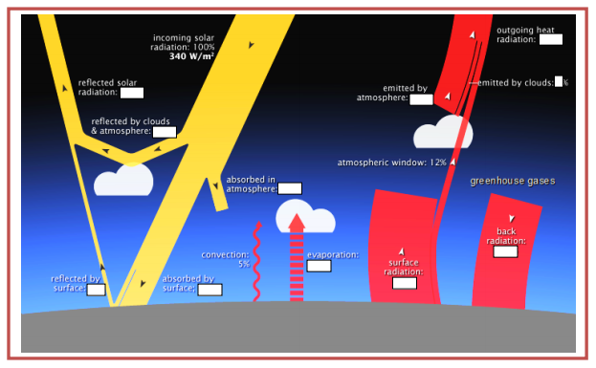

- Tie Breaker 1: Bubonic plague swept through Europe in the 14th century, killing at least ______________ 1 point
  - 30 million
  - 25 million
  - 20 million
  - 15 million

- Tie Breaker 2: What does this picture depict? 2 points
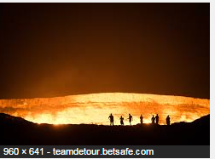

- Tie Breaker 3: What method is used to measure the amount of Carbon Dioxide in air from earlier times? What year did we start measuring Carbon Dioxide?

