Station #1

1. What is the genus of this specific specimen?

2. What class is this specimen?

3. What period on the geologic timescale did the specimen go extinct?

4. What mode of preservation did this specimen undergo to become fossilized?

5. What was the environment the specimen would be found in before it became a fossil?

6. The walls on this specimen are pierced by pores known as what?

Station #2

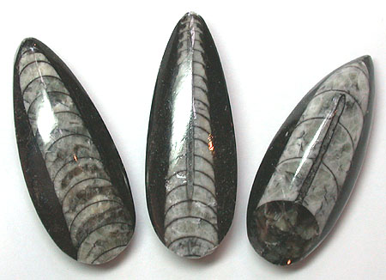

1. What is the genus of the specimen?

2. What is the phylum of this specimen?

3. What is the environment that the specimen lived in? (Be specific)

4. When did this specimen first appear?

5. How did this specimen eat?
6. What is this species closest living relative?

Station #3

1. Give an example of a trace fossil.

2. What environment might this trace fossil have been found in?

3. What other organisms can be identified within this trace fossil?

4. What type of rock was this fossil formed in?

5. What is the process called in which water dissolves the original hard parts and replaces them with mineral matter?

Station #4

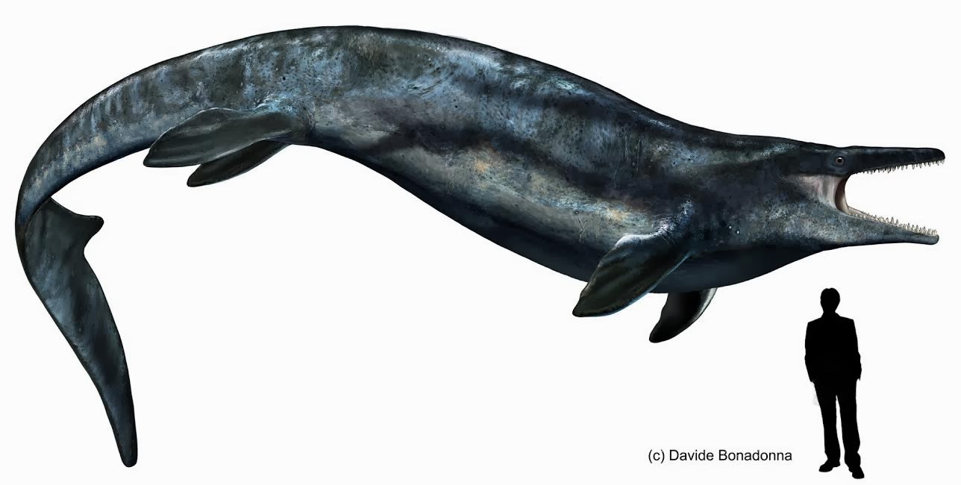

- Identify the family of this specimen.

- What means did this specimen use to get food?

- What is the class of this specimen?

4. When was the first discovery of this specimen?

5. What environment did this specimen live in?

6. What was the time period of this specimen?

Station #5
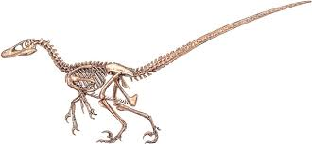

- What is the genus of this specimen?
- What is the closest living relative to the specimen?
- What external anatomical feature did this specimen share with birds?
- Alongside being carnivores, this species was also known for being what?
- What order is this species a part of?
- Was this a social creature?

Station #6

1. Identify the genus of this specimen?

2. What is the phylum of this specimen?

3. True or False: This specimen is part of the kingdom plantae. If true, what species does it mostly resemble today? If false, what kingdom does it belong to?

4. During what period did it exist?

5. What is this fossil commonly referred to as?

6. What state has this specimen as its state fossil?

Station #7

Station #8

1. Out of the three general types of rocks, what is the most common type to have fossils?

2. Identify rock #1.

3. Identify rock #2.

4. Identify rock #3.

5. Identify rock #4.

6. True of False: Rock #4 reacts to acid.

Station #9
- What is the genus of this specimen?

- Judging by the fossil presented, what type of food did the specimen eat?

- In what period did this specimen go extinct in?

- What would be the closest living relative to the specimen above?

- In what hemisphere are fossils of this specific genus commonly found?

- What is the order of this specimen?

Station #10

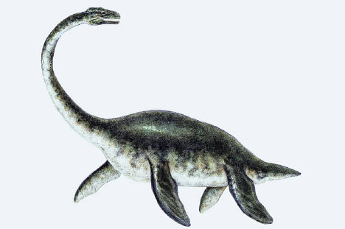

- What is the class of this specimen?

- What is the order of this specimen?

- When did this species first appear?

- What environment did this specimen live in?

- This specimen has been found on which continent(s)? Write all letters that apply.
- Antarctica
- North America
- Europe
- Asia
- Africa
- Australia
- South America
6.True or false. This specimen is among the first reptile fossils ever
found.

Station #11

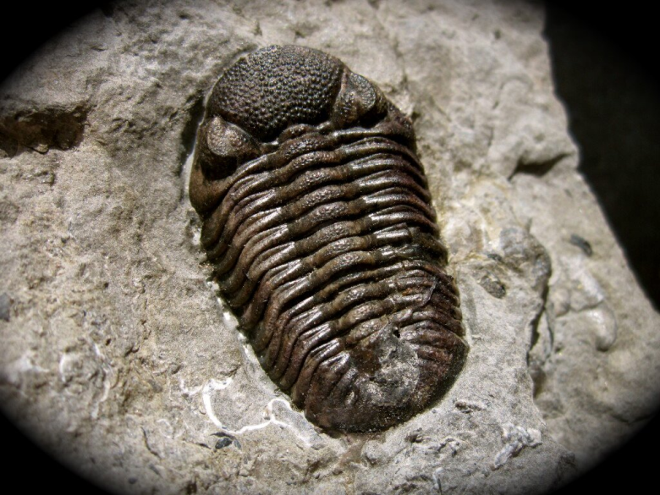

- What is the genus of this specimen?

- What is the class of this specimen?

- What is the time period where the majority of these species lived in?

- True or false. This specimen is a vertebrate

- What mode of feeding did the specimen undergo?

- What is the shell of this specimen called?

Station #12

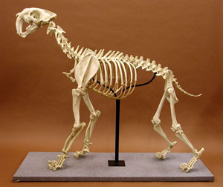

- What is the genus of this specimen?

- When did this genus go extinct?

- What common animal is this specimen closely related to?

- True or false. This animal was a predator.

- Were this animal’s large canines used for acquiring food?

- When did this species first appear?

