Station One:
1) Identify this trace fossil.
2) What era are they most commonly placed in?
3) What fossilized organisms are they made of?

Station Two:
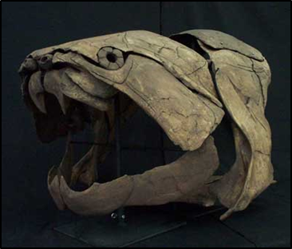
4) State the genus and class of this organism.
5) What time period is it from?
6) Who is this fossil named after?
A) Barnum Brown
B) Sir Jonathon Jacobs
C) Charles Wimbley
D) David Dunkle
Station Three:
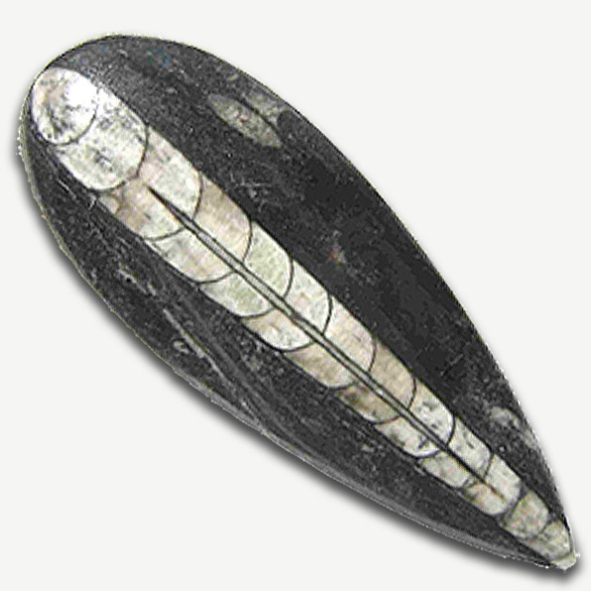
7) Identify the genus of this organism.
8) Are they more closely related to Genus Nautilis, or Genus Turritella?
9) What habitat did they live in?

Station Four:

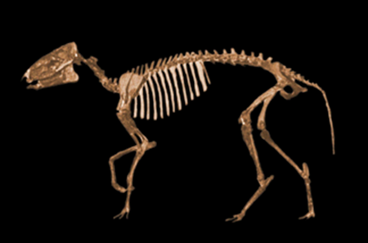
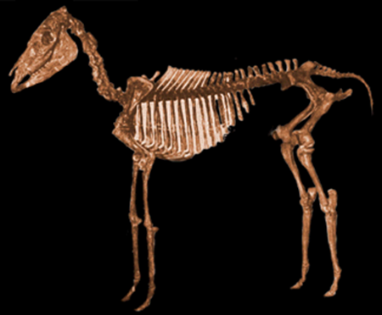

12) Identify the genus of this organism.
13) Which genus has hooves? (give the name)

10) Identify the genus of this organism.
11) Which organism is older? (give the name)

Station Five:
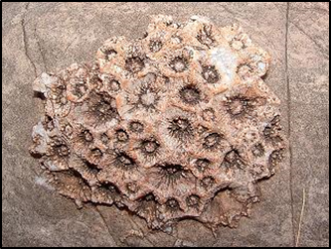
14) Identify the genus of this organism.
15) What period did they appear in?
16) What stone commonly found in Michigan is an example of this organism?

Station Six:

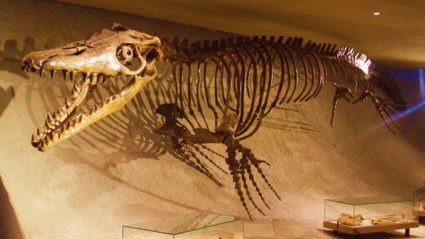
17) Identify this organism (must be more specific than class).

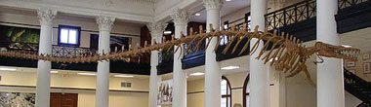
18) Identify this organism (must be more specific than class).
19) Which one is a mammal? (give the name)
Station Seven:
20) What is the isotope used for dating fossils?
21) If a substance starts with 100 atoms of this isotope, and has a half-life of 1 year, how much is left after two years go by?
22) What is coquina made up of?
23) Which sedimentary rock is made up of calcium carbonate?

Station Eight:
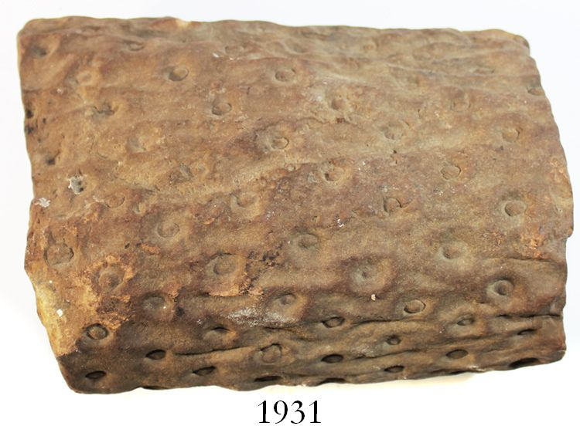
24) Identify the genus of this organism.
25) How does this organism reproduce?
26) What type of habitat did they live in?

Station Nine:
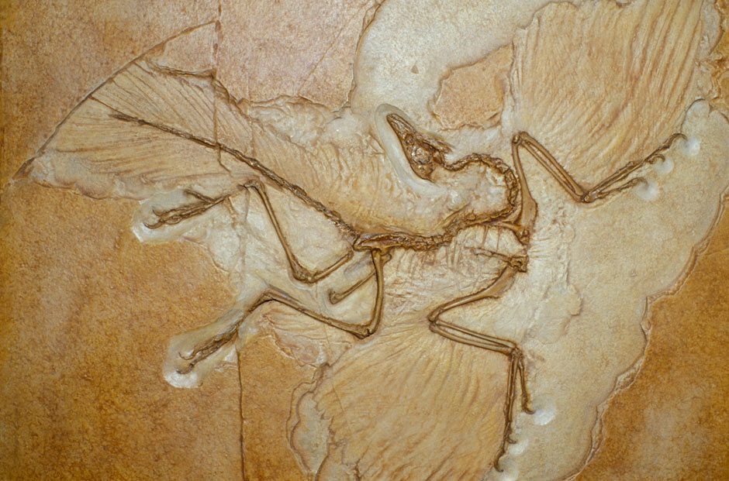
27) What is the genus of this organism.
28) This was a precursor to what modern day animals?
29) Where was this fossil discovered?

Station Ten (break station):
30) Draw me a picture of your favorite Dinosaur!

Station Eleven:
31) What is the term for when organic material is completely replaced by minerals?
32)
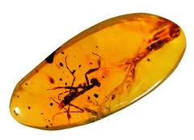
What mode of preservation is this?
33) What are “entrapped” fossils usually found in?

Station Twelve:
34)
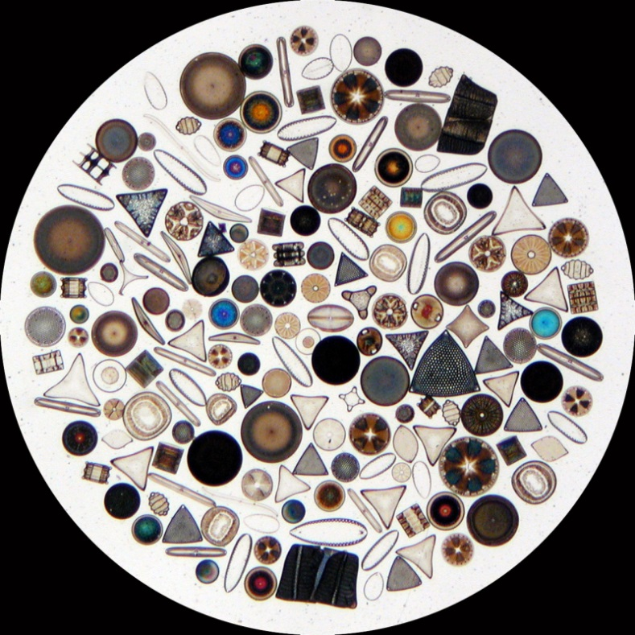
What class is this organism?
35) What type of sedimentary rock is made of these organisms?
36) They were first found in what time period?

Station Thirteen:
37) Identify the class of this organism.
38) What is the common name of this organism?
39) Are they more related to crabs, or oysters?

Station Fourteen:
40) Identify the class of this organism.
41)
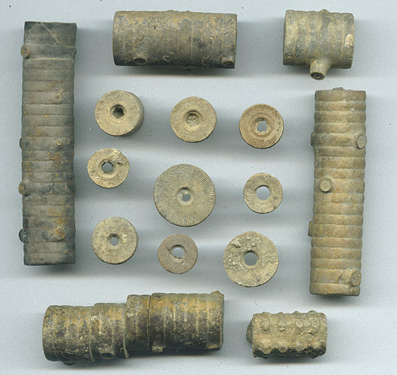
What part of the organism is this?
42)
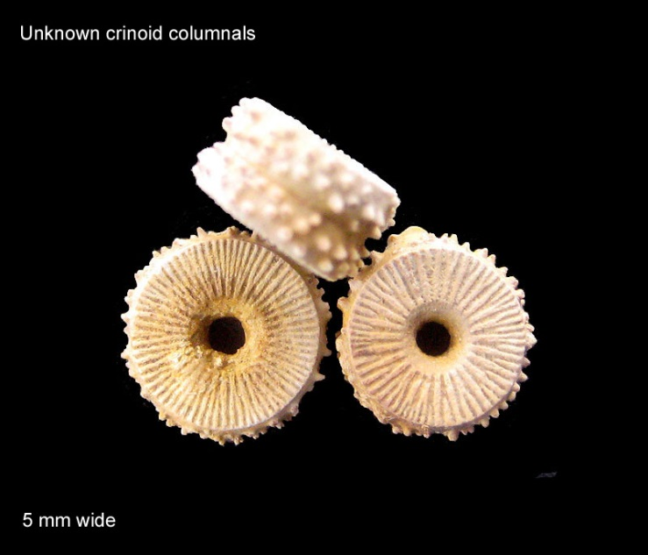
What part of the organism is this?

Station Fifteen:
43) What is this an example of?
44) What state in the US can you find a national preserved sight for this?
45) What type of preservation does not completely replace the living tissue with minerals, only parts of it?

Station Sixteen:
46) Identify the genus of this organism.
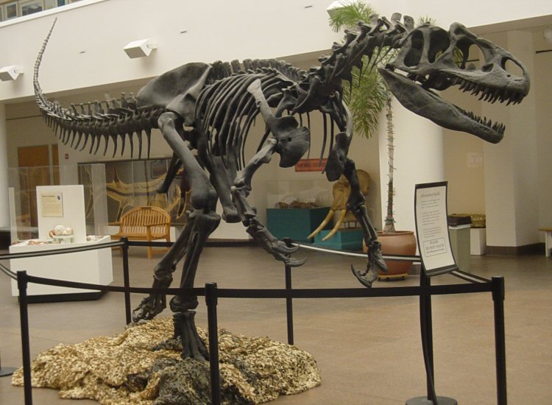
47) Identify the genus of this organism.
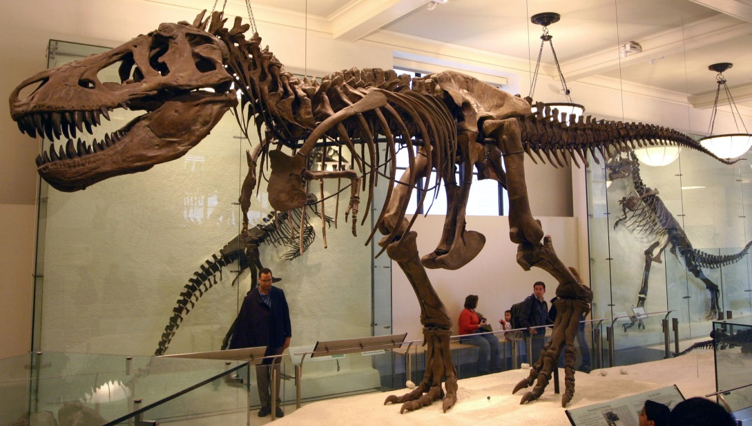
48) Which organism is from the late Jurassic Period? (give the name)
49) What famous fossil was discovered in 1990 in South Dakota?
Station Seventeen:
Identify the following trace fossils:
50)
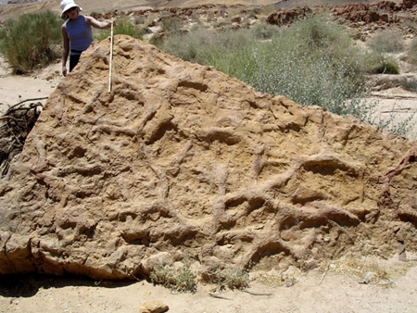
51)
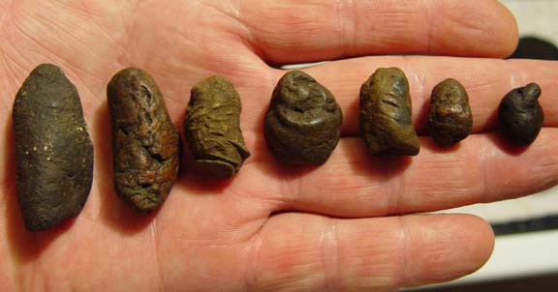
52)
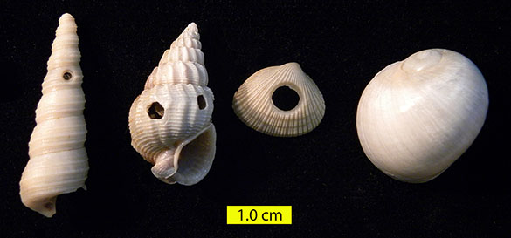

Station Eighteen:
53)
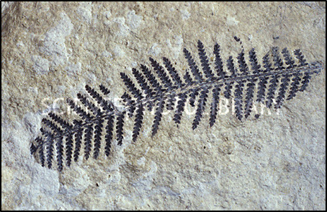
Identify the phylum of this organism.
54)
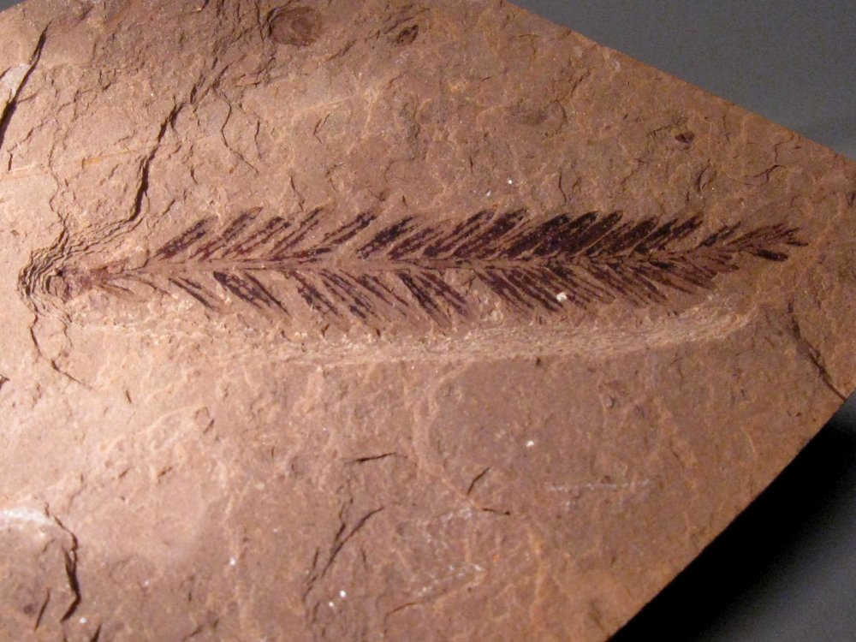
Identify the phylum of this organism.
55) Which organism reproduces with spores? (give the name)

Station Nineteen:
Identify these rocks:
56)
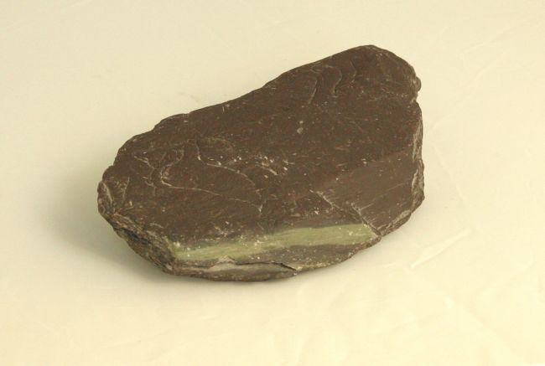
57)
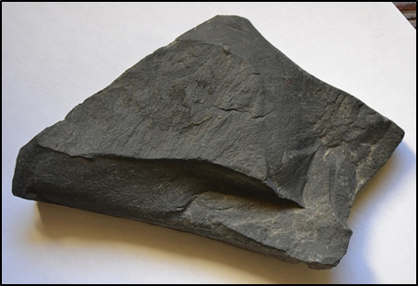
58)
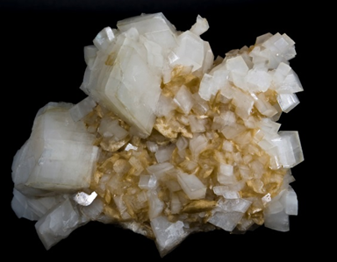

Station Twenty:
59)
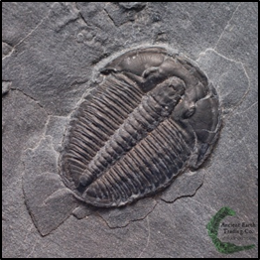
C
B
A
Identify the genus of this organism.
60) Which part is called the cephalon? (identify the letter)

