STATION # 1

Question A: Identify the order.

Question B: What is the common name of this insect?

Question C: How do these insects protect themselves from predators?

STATION # 2

Question A: Identify the family.

Question B: What is the common name of this insect?

Question C: What food do both the larvae and the adults eat, the only difference being that the larvae eat this food when it is first prechewed by the adults?

STATION # 3

Question A: Identify the family.

Question B: What is the common name of this insect?

Question C: How long can it take for this insect to complete development, turning from a nymph into an adult?

STATION # 4

Question A: Identify the order.

Question B: What is the common name of this insect?

Question C: What gender is this specimen?

STATION # 5

Question A: At a certain time, this insect is found almost exclusively on leaves, as depicted in stage 2. Why is this?

Question B: What is the purpose of the structure in
stage 4?

Question C: The insects in stages 5 and 6 are both adults. Why do they differ so much in size?

STATION # 6

Question A: Identify the order.

Question B: What is the common name of this insect?

Question C: How many tarsi does this insect have?

STATION # 7

Question A: Identify the order.

Question B: What is the common name of this insect?

Question C: What other insect resembles this insect, and why?

STATION # 8

Question A: Identify the family.

Question B: What is the common name of this insect?

Question C: What type of relationship does this insect have with aphids?

STATION # 9

Question A: Identify the order.

Question B: What is the common name of this insect?

Question C: What type of forelimbs does this insect have?

STATION # 10

Question A: Identify the order.

Question B: What is the common name of this insect?

Question C: How far north could this insect hypothetically live?

STATION # 12
A

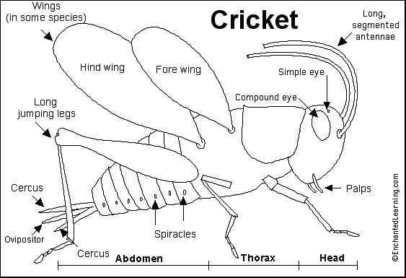
C
G
F
B
F

D
E
STATION # 11

Question A: Identify the order.

Question B: What is the common name of this insect?

Question C: What kind of an impact does this insect have on the environment?

STATION # 13

Question A: Identify the family.

Question B: What is the common name of this insect?

Question C: The larvae of this insect are called “round headed bores”. What do the larvae bore into? Is this good or bad for the environment?

STATION # 14

Question A: Identify the order.

Question B: What is the common name of this insect?

Question C: How does this insect protect itself from predators?

STATION # 15

Question A: Identify the family.

Question B: What is the common name of this insect?

Question C: What is the name of the triangle-shaped structure on the insect’s head?

STATION # 16

Question A: Identify the order.

Question B: What is the common name of this insect?

Question C: These insects are named for their inability to survive in what type of environment?

