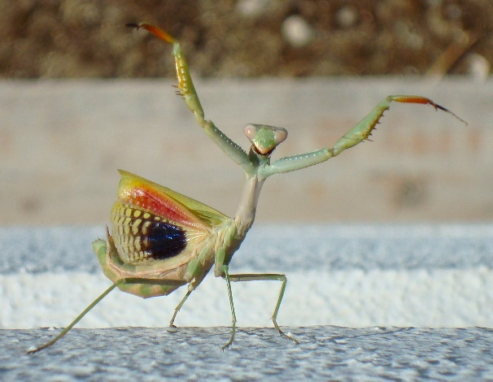

2015 Holt Invitational
Entomology B Test

School / Team Name (Please remember to indicate if you are an A or B team from your school if appropriate):

___________________________________________________

Team # _______

Student name(s):

___________________________________________

___________________________________________

Raw Score: ___________
Final Ranking: _________

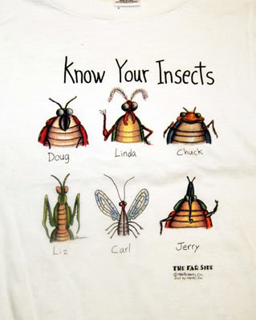

Holt Invitational School Name: _____________________________
Entomology Test 2015 School Number: ________________
Division B Participants’ Names: _____________________________
_____________________________

There are 15 stations with 3 parts and 1 with 7. Each answer is worth 1 point. The entire test is worth 52 points. The dichotomous key problem on the back will only be used as a tie-breaker.

1 A.________________________ 10 A.________________________
B.________________________ B.________________________
C.________________________ C.________________________

2 A.________________________ 11A.________________________
B.________________________ B.________________________
C.________________________ C.________________________

3 A.________________________ 12 A.________________________
B.________________________ B.________________________
C.________________________ C.________________________
D.________________________
4 A.________________________ E.________________________
B.________________________ F.________________________
C.________________________ G.________________________

5 A.________________________ 13 A.________________________
B.________________________ B.________________________
C.________________________ C.________________________

6 A.________________________ 14 A.________________________
B.________________________ B.________________________
C.________________________ C.________________________

7 A.________________________ 15 A.________________________
B.________________________ B.________________________
C.________________________ C.________________________

8 A.________________________ 16 A.________________________
B.________________________ B.________________________
C.________________________ C.________________________

9 A.________________________
B.________________________
C.________________________

TIEBREAKER:
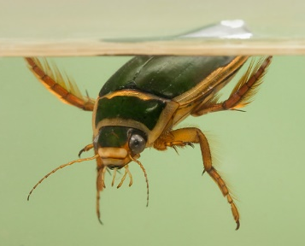
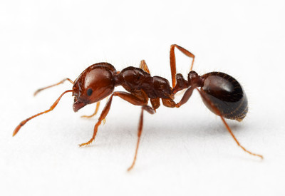
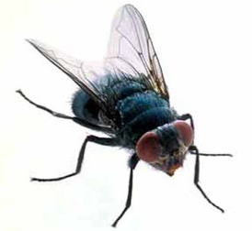
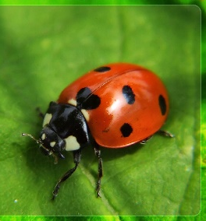
Construct a simple dichotomous key for the following insects.

