Holt Invitational: Dynamic Planet Key

- C
- C
- B, C, D
- D
- C, D
- C
- A
- C
- B
10. E
11. D
12. C
13. B
14. D

- Name 3 substances that can be found dissolved in seawater.

Need to list 3: chlorine, sodium, magnesium, sulfar, calcium, and potassium

- Where do most dissolved solids in seawater come from?

A. Gradual processes such as breaking up of cooled igneous rocks of Earth’s crust by weathering and erosion.
B. Wearing down of mountains.
C. Dissolving action of rains and streams which transported mineral washings to the sea.
D. Salts dissolved from rocks and sediments below its floor.
E. Solid and gaseous materials that escaped from Earth’s crust through volcanic vents or originated in the atmosphere.
F. Out gassing due to volcanic eruptions large quantities of water and has have been emitted during much of geologic time.

- Identify what kind of energy is outputted from waves.

Waves produce mechanical energy.

- What rock is most commonly found in oceanic basins?

Igneous rock

- Identify what the following tools are used to measure:

- Thermometer: measures temperature

ii. Secchi Disk: measures water transparency

iii. Fathometer: sonic depth finder

iv. Hydrometer: measures density of a liquid

- Name the three layers of the ocean:

1. The mixed layer
2. Main thermocline
3. Deep water layer

- Describe how an atoll forms.

An atoll forms from an underwater volcano. First the volcan erupts, piling up lava on the seafloor. As it continues to erupt, the eleveation grows higher breaking the surface of the water. The top becomes an island.

- Identify 3 things wave size depends on.

  - The duration of the wind.
  - The strength of the wind.
  - The fetch, or distance over water across which the wind blows.

- What 3 things need to occur for a tsunami to form from a seaquake?

- The Earthquake must measure at least 7.0.
- The sea bed must be lifted or lowered by the earthquake.
- The epicenter of the earthquake must be near the earth’s surface.

- How do oceans help regulate Earth’s climate?

Oceans cover about 70 percent of Earth's surface. Their large mass and thermal properties, enable them to store vast quantities of heat. Oceans buffer and regulate temperature – energy absorbed or lost by the oceans results in a smaller surface temperature change than would occur over land. The atmosphere and ocean constantly exchange energy and matter. By absorbing and releasing heat. The oceans can store an enormous amount of heat. The warm water of the Gulf Stream causes Europe to have a much warmer climate than it would otherwise.

- Gyres are caused by the Coriolis Effect.
- Station #1

Water Temperature at Various Depths

Water Depth (meters) | Temperature (° C)
50 | 18
75 | 15
100 | 12
150 | 5
200 | 4

- Using the information in the data table, construct a line graph on the grid with all important parts included. (Think – what does a graph need to be complete?)

Graph should have correctly labeled axes, title, correct scale, and data correctly plotted.

- Write a hypothesis the scientists performing the experiment may have had.

Answers can vary. Possible: As the water depth increases the temperature decreases.

- What is the independent variable?

Water Depth

- The approximate water temperature at a depth of 125 meters would be closest to: (1 pt.)
  - 15 ° C b. 8 ° C c. 13° C d. 3 ° C

Station #2 Tie Breaker #3

 | Feature
A | Continental Shelf
B | Continental Slope
C | Abyssal Plain
D | Oceanic Ridge
E | Trench

2.

Oceanic plates submerge forming trenches at the boundary.

Station #3

- (1 pt.) Where is the Mid-Atlantic ridge? C

- (2 pts.) Where is the Gulf Stream? E, Q

- (1 pt.) Where is subduction taking place? N, D

- (1 pt.) Where is there an active transform fault? G

- (1 pt.) Where is the thickest crust indicated? F

- (2 pts.) Where is the oldest oceanic crust on this map? E,M

- (1 pt.) Where is the North Atlantic Drift? S

- (1 pt.) Where is the most likely location to find a hydrothermal vent? C

- (2 pts.) There are several hotspots indicated on the map: list any two of them. M, H, B

- (1 pt.) Where is there an active continental margin? D
Station #4

- Which graph indicated temperature versus depth? Z

- Which graph indicates salinity versus depth? Y

- Which graph indicates density versus depth? X

- Which letter on the graphs indicates the pycnocline? A

- Which letter on the graphs indicates the thermocline? G

Station #5

# | Name of device | Use for the device in the Oceanography field
1 | Corer | To take sediment cores (cores from the ocean bottom)
2 | Secchi Disk | To test turbidity or cloudiness
3 | Current Meter | To measure current speed
4 | Ekman Grab | To grab samples from the ocean floor
5 | Nansen Bottle | To get water samples from deep water

Station #6 : Tie Breaker #1

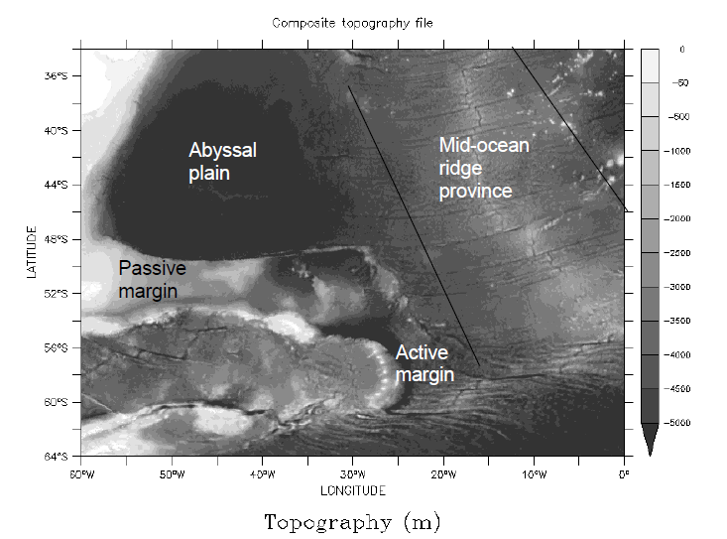

Station #7 Tie Breaker #2

- Down welling
- Loss in output or global warming is associated with it
- Upwelling
- Black/white smoker or volcano

Station #8

- Ocean Dead Zone
- Algae
- False

